Exam 5 – Practitioner

Pregunta 1:**Incorrecto**

**What does AWS Cost Explorer provide to help manage your AWS spend?**

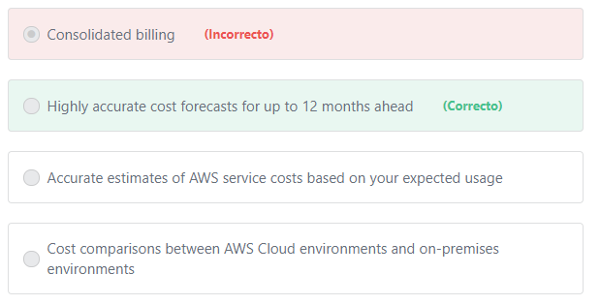

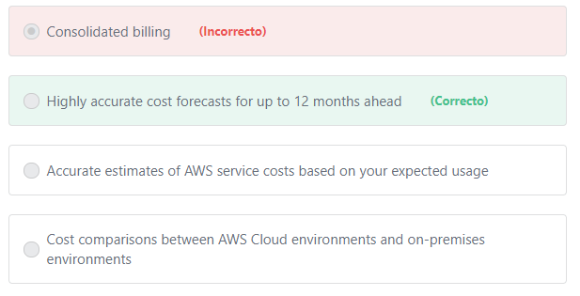Principio del formulario

**Explicación**

        AWS Cost Explorer has an easy-to-use interface that lets you visualize, understand, and manage your AWS costs and usage over time.

        Cost Explorer’s cost forecast capabilities use machine learning to learn each customer’s historical spend patterns and use that information to forecast expected costs. Cost Explorer’s forecasting enables you to get a better idea of what your costs and usage may look like in the future, so that you can plan ahead. Forecasting capabilities have been enhanced to support twelve month forecasts [**(previously forecasts were limited to three months)**](https://aws.amazon.com/about-aws/whats-new/2018/11/enhanced-forecasting-now-available-in-aws-cost-explorer/) for multiple cost metrics, including unblended and amortized costs.

***"Accurate estimates of AWS service costs based on your expected usage" is incorrect.***AWSCost Explorer forecasts your future costs based on your past usage; NOT based on your expected usage. The AWS tool that can provide accurate estimates of AWS service costs based on your expected usage is the AWS Simple Monthly Calculator. For example, if you are planning to use 500 GB of S3 storage, you can input this value directly in the AWS Simple Monthly Calculator interface and the calculator provides an estimate of what you will pay monthly for this amount of storage.

***"Cost comparisons between AWS Cloud environments and on-premises environments" is incorrect.***The AWS tool that providescost comparisons between AWS Cloud environments and on-premises environments based on your current on-premises server configurations is the AWS TCO Calculator.

***Consolidated billing is incorrect.*** Consolidated billing is a feature in AWS Organizations that enables you to consolidate billing and payment for multiple AWS accounts.

**References:**

<https://aws.amazon.com/aws-cost-management/aws-cost-explorer/>

<https://aws.amazon.com/about-aws/whats-new/2018/11/enhanced-forecasting-now-available-in-aws-cost-explorer/>

Final del formulario

Principio del formulario

Pregunta 2:**Incorrecto**

**An organization needs to build a financial application that requires support for ACID transactions. Which AWS database service is most appropriate in this case?**

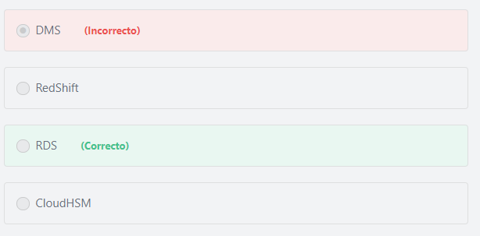

Final del formulario

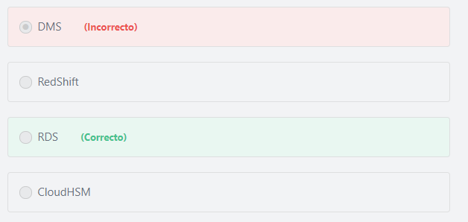Principio del formulario

**Explicación**

              In computer science, ACID (Atomicity, Consistency, Isolation, and Durability) is a set of properties of database transactions intended to guarantee validity even in the event of errors, power failures, etc. Amazon RDS is a fully-managed relational database service. It is a highly available and highly consistent database that supports ACID transactions. Basically, a transaction is one or more add, update, delete, or modify change to the database that must all be completed successfully or none of the steps should be executed. Transactional databases are useful when data integrity is important. If one of the steps in the transaction fail, then the steps must be rolled back to the state before any change was made to the database. An example of when you would need a transaction is when you make a banking transaction to move money from one account to another. If you successfully remove money from account A, but fail to add money to account B, then the transaction fails and the transaction must be rolled back so that the money is not taken from account A.

***The other options are incorrect:***

***RedShift is incorrect.*** Amazon RedShift is a cloud data warehouse service.

***DMS is incorrect.*** Amazon Database Migration Service (DMS) is used to migrate databases from your on-premises database system into AWS.

***CloudHSM is incorrect.*** AWS CloudHSM is a cloud-based hardware security module (HSM) that enables you to easily generate and use your own encryption keys on the AWS Cloud.

**References:**

<https://aws.amazon.com/relational-database/>

<https://d1.awsstatic.com/whitepapers/aws-overview.pdf>

Final del formulario

Principio del formulario

Pregunta 3:**Incorrecto**

**What are some key benefits of using AWS CloudFormation? (Choose TWO)**

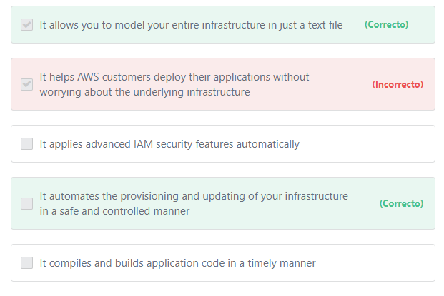

Final del formulario

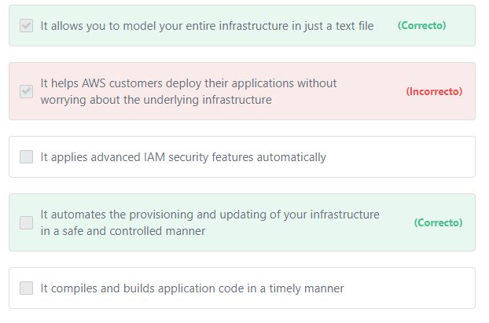Principio del formulario

**Explicación**

The benefits of using AWS CloudFormation include:

1- CloudFormation allows you to model your entire infrastructure in a text file. This template becomes the single source of truth for your infrastructure. This helps you to standardize infrastructure components used across your organization, enabling configuration compliance and faster troubleshooting.

2- AWS CloudFormation provisions your resources in a safe, repeatable manner, allowing you to build and rebuild your infrastructure and applications, without having to perform manual actions or write custom scripts. CloudFormation takes care of determining the right operations to perform when managing your stack, and rolls back changes automatically if errors are detected.

3- Codifying your infrastructure allows you to treat your infrastructure as just code. You can author it with any code editor, check it into a version control system, and review the files with team members before deploying into production.

4- CloudFormation allows you to model and provision, in an automated and secure manner, all the resources needed for your applications across all regions and accounts.

***The other options are incorrect:***

***"It applies advanced IAM security features automatically" is incorrect.*** IAM features are not applied automatically. It is the customer's responsibility to manually apply the necessary IAM features to secure their AWS resources.

***"It helps AWS customers deploy their applications without worrying about the underlying infrastructure" is incorrect.***Services like AWS Elastic Beanstalk, Lambda, and Fargate allow you to deploy your applications without needing to worry about the underlying infrastructure. For example, with AWS Elastic Beanstalk, customers can simply upload their code and Elastic Beanstalk automatically handles the deployment, from capacity provisioning, load balancing, auto-scaling to application health monitoring.

***"It compiles and builds application code in a timely manner" is incorrect.***Compiling and building application code is the responsibility of the customer.

**References:**

<https://aws.amazon.com/cloudformation/>

Final del formulario

Principio del formulario

Pregunta 4:**Incorrecto**

**Which of the following are use cases for Amazon EMR? (Choose TWO)**

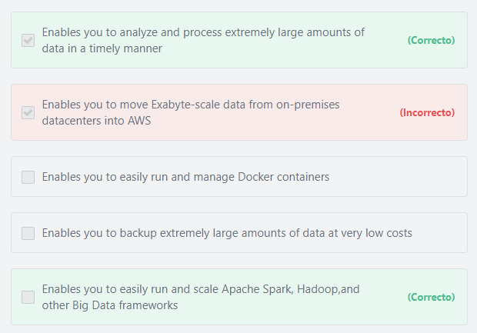

Final del formulario

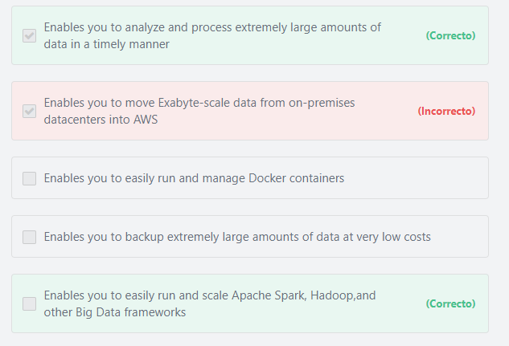Principio del formulario

**Explicación**

          Amazon Elastic Map Reduce (Amazon EMR) is a web service that enables businesses, researchers, data analysts, and developers to easily and cost-effectively process vast amounts of data. It utilizes a hosted Hadoop framework running on the web-scale infrastructure of Amazon Elastic Compute Cloud (Amazon EC2) and Amazon Simple Storage Service (Amazon S3).

        Amazon EMR is ideal for problems that necessitate the fast and efficient processing of large amounts of data. EMR securely and reliably handles a broad set of big data use cases, including log analysis, web indexing, data transformations (ETL), machine learning, financial analysis, scientific simulation, and bioinformatics.

          Amazon EMR lets you focus on crunching or analyzing your data without having to worry about time-consuming set-up, management or tuning of Hadoop clusters or the compute capacity upon which they sit.

***The other options are incorrect:***

***"Enables you to backup extremely*** ***large amounts of data at very low costs" is incorrect.*** EMR is not a storage service. Amazon EMR is a web service that enables you to process vast amounts of data across dynamically scalable Amazon EC2 instances. You can use Amazon Glacier or Amazon Glacier Deep Archive to backup large amounts of data at very low costs.

***"Enables you to move Exabyte-scale data from on-premises datacenters into AWS" is incorrect.***AWSSnowmobile is the service that can be used to transfer Exabyte-scale data from on-premises datacenters into AWS.

***"Enables you to run and manage Docker containers" is incorrect.***Amazon Elastic Container Service (ECS) is the service that can be used to run and manage Docker containers in AWS.

**References:**

<https://aws.amazon.com/emr/>

Final del formulario

Principio del formulario

Pregunta 5:**Correcto**

**Which of the following will affect how much you are charged for storing objects in S3? (Choose TWO)**

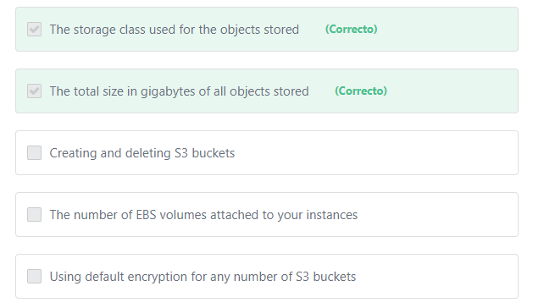

Final del formulario

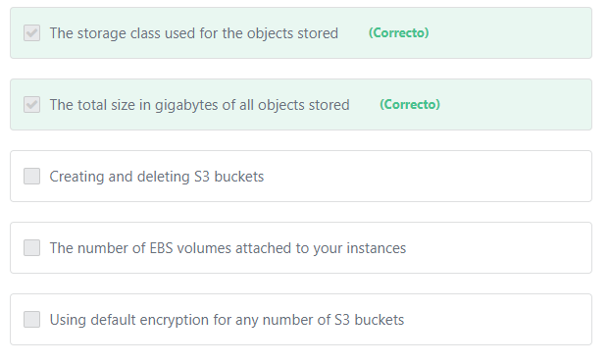Principio del formulario

**Explicación**

          S3 pricing is based on four factors:

1) Total amount of data (in GB) stored on S3

2) Storage class (S3 Standard, S3 Intelligent-Tiering, S3 Standard-Infrequent Access, S3 One Zone-IA, S3 Glacier, or S3 Glacier Deep Archive)

3) Amount of data transferred out of AWS from S3

4) Number of requests to S3

***The other options are incorrect:***

***"Using default encryption for any number of S3 buckets" is incorrect.***There are no extra charges for using default encryption for S3 buckets.

***"Creating and deleting S3 buckets" is incorrect.*** Creating or deleting S3 buckets is free but you will be charged for data that you store in those buckets.

***"The number of EBS volumes attached to your instances" is incorrect.***Amazon EBS is a different AWS storage service. Amazon EBS is a block level storage service that provides storage volumes for use with Amazon EC2 and Amazon RDS.

**References:**

<https://aws.amazon.com/s3/pricing/>

<https://docs.aws.amazon.com/AmazonS3/latest/dev/storage-class-intro.html>

<https://docs.aws.amazon.com/AmazonS3/latest/dev/bucket-encryption.html>

Final del formulario

Principio del formulario

Pregunta 6:**Incorrecto**

**A developer wants to quickly deploy and manage his application in the AWS Cloud, but he doesn’t have any experience with cloud computing. Which of the following AWS services would help the developer achieve his goal?**

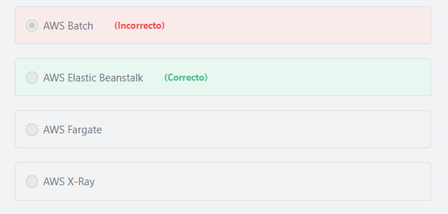

Final del formulario

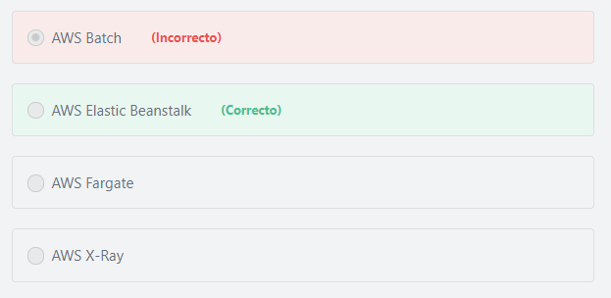Principio del formulario

**Explicación**

             AWS Elastic Beanstalk is an easy-to-use service for deploying and scaling web applications and services developed with Java, .NET, PHP, Node.js, Python, Ruby, Go, and Docker on familiar servers such as Apache, Nginx, Passenger, and IIS. You can simply upload your code and Elastic Beanstalk automatically handles the deployment, from capacity provisioning, load balancing, auto-scaling to application health monitoring. At the same time, you retain full control over the AWS resources powering your application and can access the underlying resources at any time.

***The other options are incorrect:***

***AWS X-Ray is incorrect.***AWS X-Ray is a debugging service that helps developers understand how their application and its underlying services are performing to identify and troubleshoot the root cause of performance issues and errors.

***AWS Fargate is incorrect.*** AWS Fargate is a compute engine for Amazon ECS that allows you to run containers without having to manage servers or clusters.

***AWS Batch is incorrect.***AWS Batch provides batch processing at any scale.

**References:**

<https://aws.amazon.com/elasticbeanstalk/faqs/>

Final del formulario

Principio del formulario

Pregunta 7:**Incorrecto**

**You need to migrate a large number of on-premises workloads to AWS. Which AWS service is the most appropriate?**

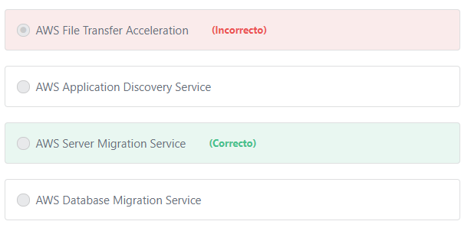

Final del formulario

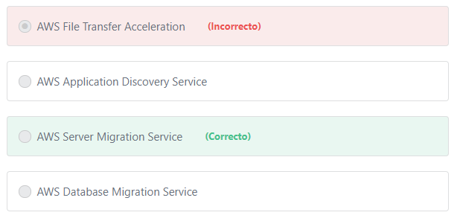Principio del formulario

**Explicación**

          AWS Server Migration Service (SMS) is an agentless service which makes it easier and faster for you to migrate thousands of on-premises workloads to AWS. AWS SMS allows you to automate, schedule, and track incremental replications of live server volumes, making it easier for you to coordinate large-scale server migrations.

         AWS Server Migration Service currently supports virtual machine migrations from VMware vSphere, Windows Hyper-V, or Microsoft Azure to AWS. Each server volume migrated is saved as a new Amazon Machine Image (AMI), which can be launched as an EC2 instance (virtual machine) in the AWS cloud.

***The other options are incorrect:***

***"AWS Database Migration Service" is incorrect.*** AWS Database Migration Service is used to migrate your data to and from most of the widely used commercial and open source databases.

***"AWS Application Discovery Service" is incorrect.***AWS Application Discovery Service is used to discover on-premises server inventory and behavior. This service is very useful when creating a migration plan to AWS.

***"AWS File Transfer Acceleration" is incorrect.***AWS File Transfer Acceleration is an S3 feature that enables fast, easy, and secure transfers of files over long distances between your client and an S3 bucket.

**References:**

<https://aws.amazon.com/server-migration-service/>

Final del formulario

Principio del formulario

Pregunta 8:**Incorrecto**

**You want to transfer 200 Terabytes of data from on-premises locations to the AWS Cloud, which of the following can do the job in a cost-effective way?**

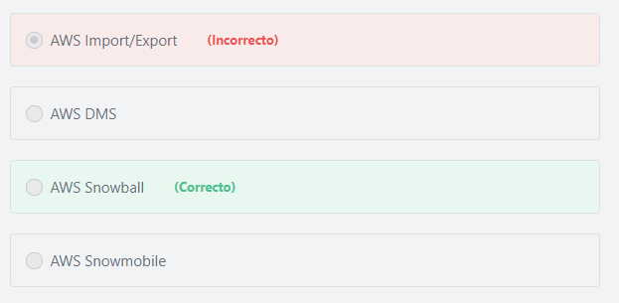

Final del formulario

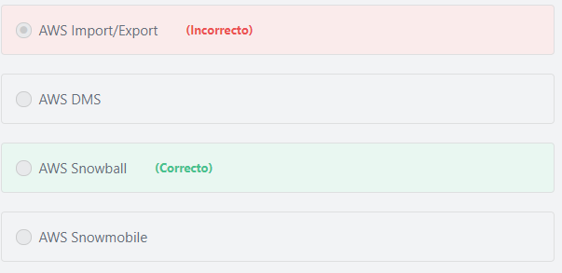Principio del formulario

**Explicación**

        AWS Snowball is a petabyte-scale data transport solution that uses secure appliances to transfer large amounts of data into and out of the AWS cloud. Using Snowball addresses common challenges with large-scale data transfers, including high network costs, long transfer times, and security concerns. Transferring data with Snowball is simple, fast, secure, and can cost as little as one-fifth the cost of using high-speed internet.

       Additionally, With AWS Snowball, you can access the compute power of the AWS Cloud locally and cost-effectively in places where connecting to the internet might not be an option. AWS Snowball is a perfect choice if you need to run computing in rugged, austere, mobile, or disconnected (or intermittently connected) environments.

       With AWS Snowball, you have the choice of two devices, Snowball Edge Compute Optimized with more computing capabilities, suited for higher performance workloads, or Snowball Edge Storage Optimized with more storage, which is suited for large-scale data migrations and capacity-oriented workloads.

Snowball Edge Storage Optimized devices provides up to 80 TB of usable storage.

      In our case, it is better (cost-effective) to use 3 snowball Edge Storage Optimized devices to transfer 200 TB instead of using the internet.

3 snowballs * 80TB = 240 TB

    There are many options for transferring your data into AWS. Snowball is intended for transferring large amounts of data. If you want to transfer less than 10 terabytes of data between your on-premises data centers and Amazon S3, Snowball might not be your most economical choice.

***The other options are incorrect:***

***AWS Import/Export is incorrect.***AWS Import/Export has been replaced by the Snowball service.

***AWS Snowmobile is incorrect.*** Snowmobile is not a cost effective solution here. AWS Snowmobile is an Exabyte-scale data transfer service used to move extremely large amounts of data to AWS. You can transfer up to 100 Petabytes (100,000 *Terabytes*) per Snowmobile, a 45-foot long ruggedized shipping container, pulled by a semi-trailer truck.

***AWS DMS is incorrect.*** AWS Database Migration Service (DMS) is used to migrate databases to AWS.

**References:**

<https://aws.amazon.com/snowball/>

<https://aws.amazon.com/snowmobile/>

Final del formulario

Principio del formulario

Pregunta 9:**Correcto**

**Which of the following AWS services uses Puppet to automate how EC2 instances are configured?**

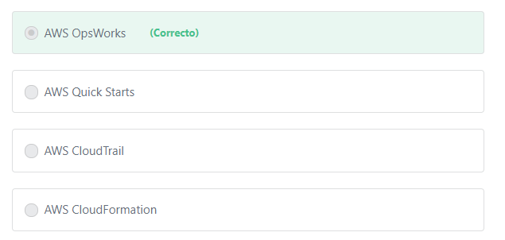

Final del formulario

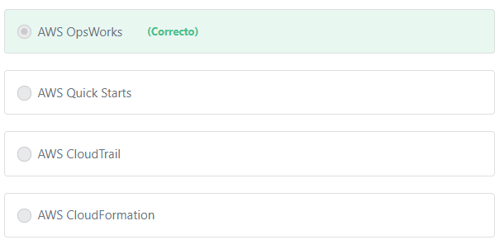Principio del formulario

**Explicación**

         AWS OpsWorks is a configuration management service that provides managed instances of Chef and Puppet. Chef and Puppet are automation platforms that allow you to use code to automate the configurations of your servers. OpsWorks lets you use Chef and Puppet to automate how servers are configured, deployed, and managed across your Amazon EC2 instances or on-premises compute environments.

***The other options are incorrect:***

***AWS CloudTrail is incorrect.*** AWS CloudTrail is a service that logs all API calls related to your account.

***AWS CloudFormation is incorrect.*** AWS CloudFormation is used to define and manage your infrastructure as code.

***AWS Quick Starts is incorrect.*** AWS Quick Starts are automated reference deployments built by AWS solutions architects and partners to help you deploy popular technologies on AWS. Each Quick Start launches, configures, and runs the AWS compute, network, storage, and other services required to deploy specific workloads on AWS, using AWS best practices for security and availability.

**References:**

<https://aws.amazon.com/opsworks/>

Final del formulario

Principio del formulario

Pregunta 10:**Incorrecto**

**Which of the following can help secure your sensitive data in Amazon S3? (Choose TWO)**

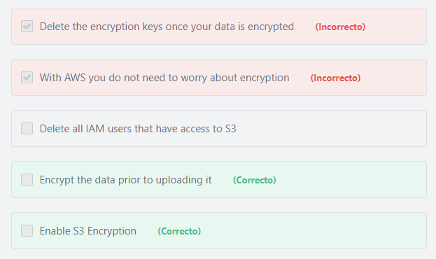

Final del formulario

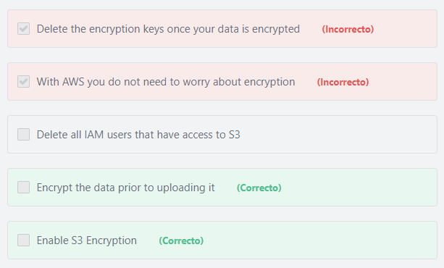Principio del formulario

**Explicación**

           Data protection refers to protecting data while in-transit (as it travels to and from Amazon S3) and at rest (while it is stored on disks in Amazon data centers). You can protect data in transit by using SSL/TLS or by using client-side encryption.

Also, you have the following options of protecting data at rest in Amazon S3.

1- Use Server-Side Encryption – You configure Amazon S3 to encrypt your object before saving it on disks in its data centers and decrypt it when you download the objects.

2- Use Client-Side Encryption – You can encrypt your data on the client-side and upload the encrypted data to Amazon S3. In this case, you manage the encryption process, the encryption keys, and related tools.

***The other options are incorrect:***

***"Delete the encryption keys once your data is encrypted" is incorrect.*** These keys are required to perform the decryption process.

***"With AWS you do not need to worry about encryption" is incorrect.*** AWS does not encrypt the customer data automatically unless it is configured to do so. The customer is responsible for everything related to their data - access management, encryption, validation, lifecycle management, etc.

***"Delete all IAM users that have access to S3" is incorrect.*** Instead of deleting your IAM users, you should restrict access to the S3 buckets using IAM policies.

**References:**

<https://docs.aws.amazon.com/AmazonS3/latest/dev/UsingEncryption.html>

Final del formulario

Principio del formulario

Pregunta 11:**Incorrecto**

**You want to create a backup of your data in another geographical location. Where should you create this backup?**

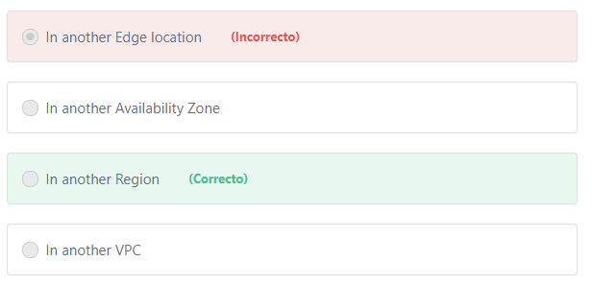

Final del formulario

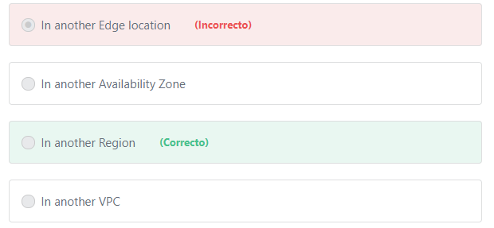Principio del formulario

**Explicación**

       A Region is a physical location around the world where AWS clusters data centers. AWS calls each group of logical data centers an Availability Zone. Each AWS Region consists of multiple, isolated, and physically separate Availability Zones within a geographic area. Unlike other cloud providers, who often define a region as a single data center, the multiple Availability Zones design of every AWS Region offers advantages for customers. Each Availability Zone has independent power, cooling, and physical security and is connected via redundant, ultra-low-latency networks. AWS customers focused on high availability can design their applications to run in multiple Availability Zones to achieve even greater fault-tolerance.

To save a backup to another geographical location, save it to a different AWS Region.

**The other options are incorrect.**

***"In another Edge location" is incorrect.***Edge locations are used in conjunction with the CloudFront service to cache and deliver content to global users with low latency. They are not used to store backups.

***"In another Availability Zone" is incorrect.*** Availability Zones exist within a Region and are in the same geographic area.

***"In another VPC" is incorrect.***Amazon Virtual Private Cloud (Amazon VPC) is not a geographic location. Amazon VPC is a networking service that enables you to create an isolated virtual network in the AWS Cloud.

**References:**

<https://docs.aws.amazon.com/AmazonRDS/latest/UserGuide/Concepts.RegionsAndAvailabilityZones.html>

Final del formulario

Principio del formulario

Pregunta 12:**Incorrecto**

**Amazon RDS supports multiple database engines to choose from. Which of the following is not one of them?**

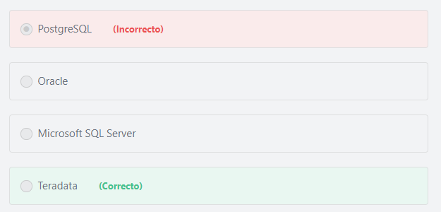

Final del formulario

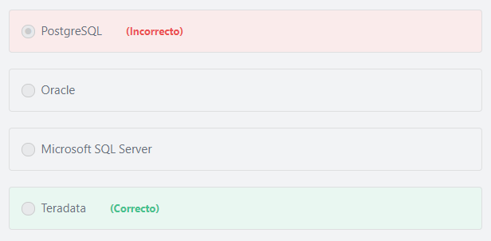Principio del formulario

**Explicación**

        Amazon Relational Database Service (Amazon RDS) is a managed service that makes it easy to set up, operate, and scale a relational database in the cloud. Amazon RDS is available on several database instance types - optimized for memory, performance or I/O - and provides you with six familiar database engines to choose from, including Amazon Aurora, PostgreSQL, MySQL, MariaDB, Oracle, and Microsoft SQL Server.

**References:**

<https://aws.amazon.com/rds/>

Final del formulario

Principio del formulario

Pregunta 13:**Incorrecto**

**Which of the following would you use to manage your encryption keys in the AWS Cloud? (Choose TWO)**

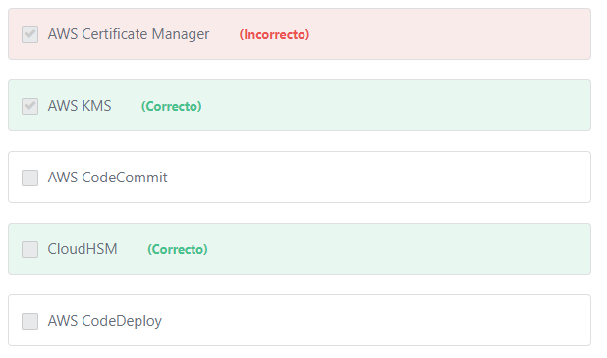

Final del formulario

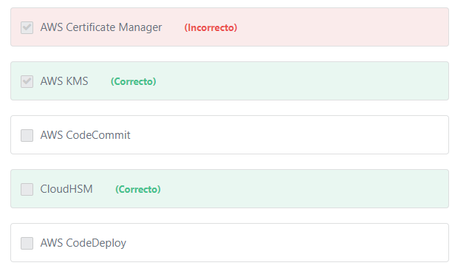Principio del formulario

**Explicación**

          AWS Key Management Service (KMS) is a managed service that makes it easy for you to create and control the encryption keys used to encrypt your data, and uses FIPS 140-2 validated hardware security modules to protect the security of your keys. AWS Key Management Service is integrated with most other AWS services to help you protect the data you store with these services. AWS Key Management Service is also integrated with AWS CloudTrail to provide you with logs of all key usage to help meet your regulatory and compliance needs.

          AWS CloudHSM is a cloud-based hardware security module (HSM) that enables you to easily generate and use your own encryption keys on the AWS Cloud. With CloudHSM, you can manage your own encryption keys using FIPS 140-2 Level 3 validated HSMs. CloudHSM offers you the flexibility to integrate with your applications using industry-standard APIs, such as PKCS#11, Java Cryptography Extensions (JCE), and Microsoft CryptoNG (CNG) libraries.

***The other options are incorrect:***

***AWS Codecommit is incorrect.*** AWS CodeCommit is mainly used for software version control, not for managing encryption keys.

Additional information:

          AWS CodeCommit is designed for software developers who need a secure, reliable, and scalable source control system to store and version their code. In addition, AWS CodeCommit can be used by anyone looking for an easy to use, fully managed data store that is version controlled. For example, IT administrators can use AWS CodeCommit to store their scripts and configurations. Web designers can use AWS CodeCommit to store HTML pages and images.

***AWS CodeDeploy is incorrect.***AWS CodeDeploy is a service that automates code deployments to any instance, including Amazon EC2 instances and instances running on-premises, and is not used for managing encryption keys.

***AWS Certificate Manager is incorrect.***AWS Certificate Manager is a service that lets you easily provision, manage, and deploy public and private Secure Sockets Layer/Transport Layer Security (SSL/TLS) certificates for use with AWS services and your internal connected resources.

**References:**

<https://aws.amazon.com/kms/>

<https://aws.amazon.com/cloudhsm/>

Final del formulario

Principio del formulario

Pregunta 14:**Incorrecto**

**You have migrated your application to AWS recently. How can you view the AWS costs applied to your account?**

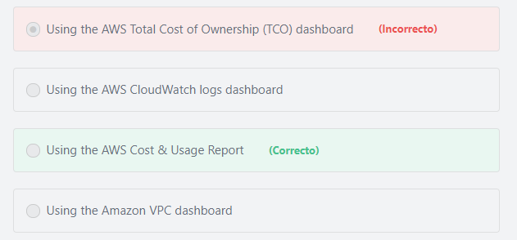

Final del formulario

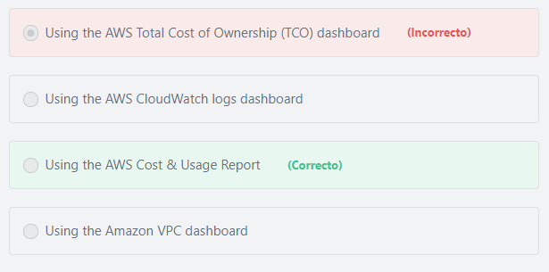Principio del formulario

**Explicación**

                The AWS Cost & Usage Report is your one-stop shop for accessing the most detailed information available about your AWS costs and usage. The AWS Cost & Usage Report lists AWS usage for each service category used by an account and its IAM users in hourly or daily line items, as well as any tags that you have activated for cost allocation purposes.

***The other options are incorrect:***

***"Using the AWS Total Cost of Ownership (TCO) dashboard" is incorrect.*** AWS TCO is a calculator used to compare the cost of running your applications in an on-premises or colocation environment to AWS. The TCO calculator matches your current infrastructure to the most cost effective AWS offering. This tool considers all the costs to run a solution in AWS, including physical facilities, power, and cooling, to provide a realistic, end-to-end comparison of your costs.

***"Using the AWS CloudWatch logs dashboard" is incorrect.***You can use Amazon CloudWatch Logs to monitor, store, and access your log files from Amazon Elastic Compute Cloud (Amazon EC2) instances, AWS CloudTrail, Route 53, and other sources. CloudWatch Logs enables you to centralize the logs from all of your systems, applications, and AWS services that you use, in a single, highly scalable service. You can then easily view them, search them for specific error codes or patterns, filter them based on specific fields, or archive them securely for future analysis. By default, logs are kept indefinitely and never expire. You can adjust the retention policy for each log group, keeping the indefinite retention, or choosing a retention periods between 10 years and one day.

***"Using the Amazon VPC dashboard" is incorrect.***Amazon VPC dashboard doesn’t provide any cost information.

**References:**

<https://aws.amazon.com/aws-cost-management/aws-cost-and-usage-reporting/>

Final del formulario

Principio del formulario

Pregunta 15:**Incorrecto**

**Which of the following has the greatest impact on cost? (Choose TWO)**

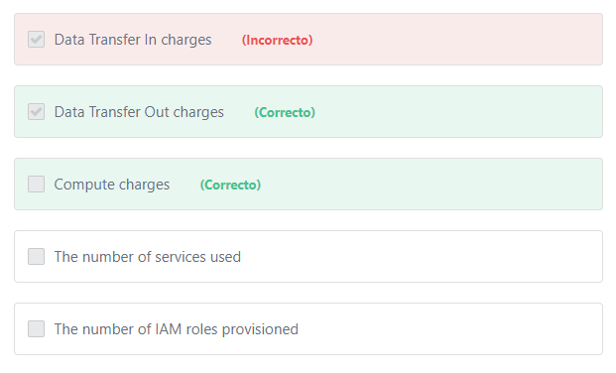

Final del formulario

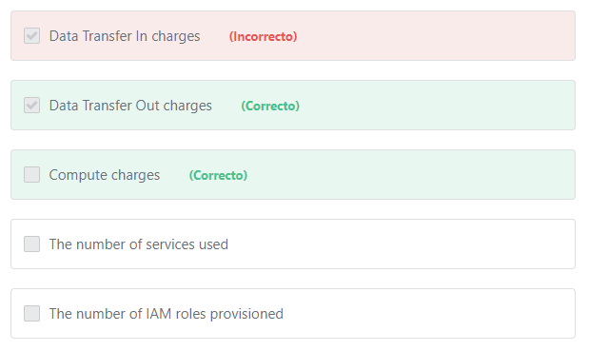Principio del formulario

**Explicación**

     The factors that have the greatest impact on cost include: Compute, Storage  and Data Transfer Out. Their pricing differs according to the service you use.

***The other options are incorrect:***

***"***​***The number of services used" is incorrect.*** It does not matter how many AWS services you are using. Each AWS service has its own pricing details, and many of them are free to use.

***"Data Transfer In charges" is incorrect.*** AWS does not charge any money for "Data Transfer In" for most services.

***"The number of IAM roles provisioned" is incorrect.*** IAM roles are free.

**References:**

<https://aws.amazon.com/pricing/>

Final del formulario

Principio del formulario

Pregunta 16:**Correcto**

**A media company has an application that requires the transfer of large data sets to and from AWS every day. This data is business critical and should be transferred over a consistent connection. Which AWS service should the company use?**

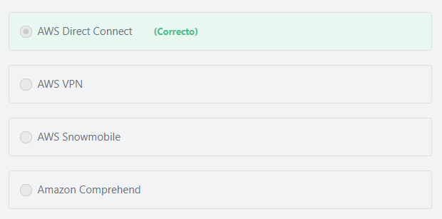

Final del formulario

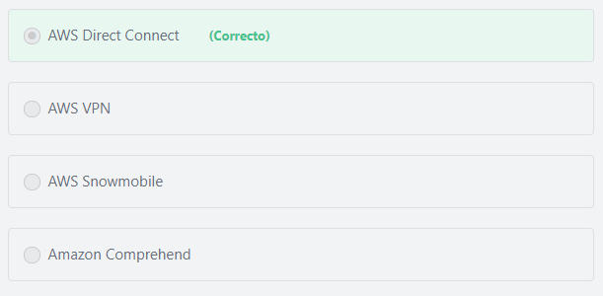Principio del formulario

**Explicación**

              AWS Direct Connect makes it easy for businesses to establish a dedicated network connection from their on-premises datacenters to AWS. Using AWS Direct Connect, customers can establish private connectivity between AWS and their datacenter, office, or co-location environment, which in many cases can reduce their network costs, increase bandwidth throughput, and provide a more consistent network experience than Internet-based connections.

***The other options are incorrect:***

***“AWS VPN” is incorrect***. AWS Virtual Private Network (AWS VPN) provides an **internet-based connection** that enables customers to connect their on-premises network or branch office site to AWS. Internet-based connectivity can have ***unpredictable performance*** and despite being encrypted, can present security concerns.

AWS Direct Connect bypasses the public Internet and uses a standard Ethernet fiber-optic cable to establish a secure, dedicated, and **more consistent connectivity** from on-premises data centers into AWS.

AWS VPN is incorrect because transferring large data sets over the Internet can be time consuming and expensive. Additionally, AWS VPN is an internet-based connection and does not meet the requirement of consistent connectivity.

Additional information:

Unlike AWS Direct Connect, VPN Connections can be configured in **minutes** and are a good solution if customers have an immediate need, have low to modest bandwidth requirements, and can tolerate the inherent variability in Internet-based connectivity.

***"AWS Snowmobile" is incorrect.***AWS Snowmobile is an Exabyte-scale data transfer service used to move extremely large amounts of data to AWS, including video libraries, image repositories, or even a complete data center migration. Customers can transfer up to 100 PetaBytes per Snowmobile, a 45-foot long ruggedized shipping container, pulled by a semi-trailer truck.

***“Amazon Comprehend” is incorrect.***Amazon Comprehend is a natural language processing (NLP) service that uses machine learning to find meaning and insights in text. Customers can use Amazon Comprehend to identify the language of the text, extract key phrases, places, people, brands, or events, understand sentiment about products or services, and identify the main topics from a library of documents. The source of this text could be web pages, social media feeds, emails, or articles. Amazon Comprehend is fully managed, so there are no servers to provision, and no machine learning models to build, train, or deploy.

**References:**

<https://aws.amazon.com/directconnect/>

Final del formulario

Principio del formulario

Pregunta 17:**Incorrecto**

**You manage a blog on AWS that has different environments: development, testing, and production. What can you use to create a custom console for each environment to view and manage your resources easily?**

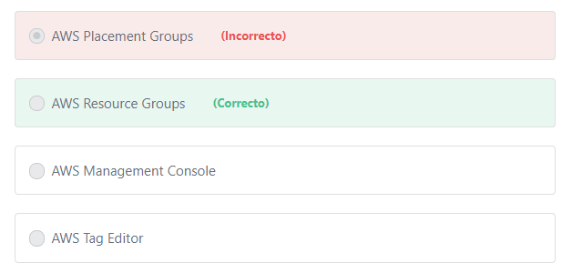

Final del formulario

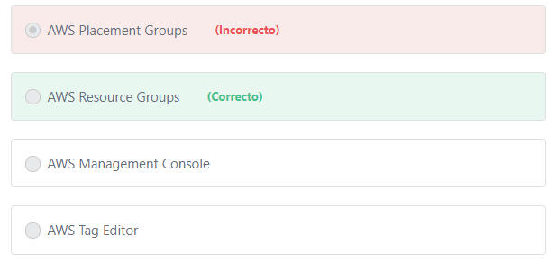Principio del formulario

**Explicación**

                If you work with multiple resources in multiple environments, you might find it useful to manage all the resources in each environment as a group rather than move from one AWS service to another for each task. Resource Groups help you do just that. By default, the AWS Management Console is organized by AWS service. But with the Resource Groups tool, you can create a custom console that organizes and consolidates information based on your project and the resources that you use.

***The other options are incorrect:***

***"AWS Management Console" is incorrect.***AWS Management Console lets you access and manage individual AWS resources through a web-based user interface.

***"AWS Tag Editor" is incorrect.***AWS Tag Editor is used to add, edit, or delete tags from AWS resources.

***"AWS Placement Groups"is incorrect.*** Placement Groups are logical groupings or clusters of EC2 instances within a single Availability Zone. Placement groups are recommended for applications that require low network latency, high network throughput, or both.

**References:**

<https://docs.aws.amazon.com/ARG/latest/APIReference/Welcome.html>

Final del formulario

Principio del formulario

Pregunta 18:**Incorrecto**

**An organization uses a hybrid cloud architecture to run their business. Which AWS service enables them to deploy their applications to any AWS or on-premises server?**

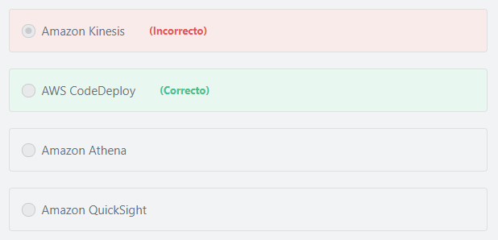

Final del formulario

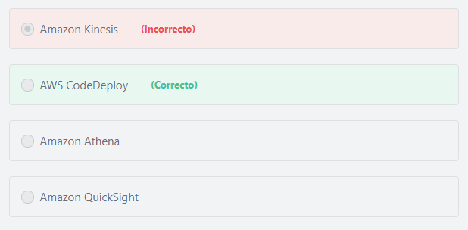Principio del formulario

**Explicación**

                AWS CodeDeploy is a service that automates application deployments to any instance, including Amazon EC2 instances and instances running on-premises. AWS CodeDeploy makes it easier for you to rapidly release new features, helps you avoid downtime during deployment, and handles the complexity of updating your applications. You can use AWS CodeDeploy to automate deployments, eliminating the need for error-prone manual operations, and the service scales with your infrastructure so you can easily deploy to one instance or thousands.

             You can also use AWS OpsWorks to automate application deployments to any instance, including Amazon EC2 instances and instances running on-premises. OpsWorks is a service that helps you automate operational tasks like code deployment, software configurations, package installations, database setups, and server scaling using Chef and Puppet.

***The other options are incorrect:***

***Amazon Athena is incorrect.*** Amazon Athena is an **analytics** service that makes it easy to query data in Amazon S3 using standard SQL commands.

***Amazon Kinesis*** ***is incorrect.***Amazon Kinesis is an **analytics** service that allows you to easily collect, process, and analyze video and data streams in real time.

***"Amazon QuickSight" is incorrect.***Amazon QuickSight is a very fast, easy-to-use, cloud-powered business **analytics** service that makes it easy for all employees within an organization to build visualizations, perform ad-hoc analysis, and quickly get business insights from their data, anytime, on any device. Unlike traditional business intelligence tools or data discovery solutions, getting started with Amazon QuickSight is simple and fast. When you log in, Amazon QuickSight seamlessly discovers your data sources in AWS services such as Amazon Redshift, Amazon RDS, Amazon Athena, and Amazon Simple Storage Service (Amazon S3). You can connect to any of the data sources discovered by Amazon QuickSight and get insights from this data in minutes. Amazon QuickSight supports rich data discovery and business analytics capabilities to help customers derive valuable insights from their data without worrying about provisioning or managing infrastructure. Organizations pay a low monthly fee for each Amazon QuickSight user, eliminating the cost of long-term licenses. With Amazon QuickSight, organizations can deliver rich business analytics functionality to all employees without incurring a huge cost upfront.

**References:**

<https://aws.amazon.com/codedeploy/>

<https://aws.amazon.com/about-aws/whats-new/2015/04/aws-codedeploy-supports-on-premises-instances/>

<https://aws.amazon.com/about-aws/whats-new/2014/12/08/aws-opsworks-supports-existing-ec2-instances-and-on-premises-servers/>

Final del formulario

Principio del formulario

Pregunta 19:**Incorrecto**

**You are running a financial services web application on AWS. The application uses a MySQL database to store the data. Which of the following AWS services would improve the performance of your application by allowing you to retrieve information from fast in-memory caches?**

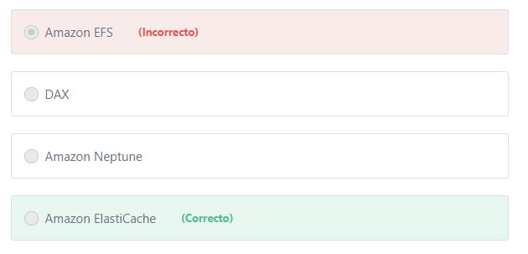

Final del formulario

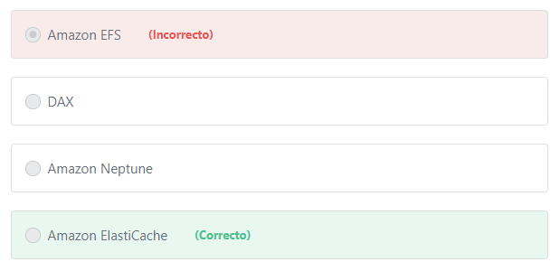Principio del formulario

**Explicación**

              Amazon ElastiCache offers fully managed Redis and Memcached. Seamlessly deploy, operate, and scale popular open source compatible in-memory data stores. Build data-intensive apps or improve the performance of your existing apps by retrieving data from high throughput and low latency in-memory data stores. Amazon ElastiCache is a popular choice for Gaming, Ad-Tech, Financial Services, Healthcare, and IoT apps.

            The primary purpose of an in-memory data store is to provide ultrafast (submillisecond latency) and inexpensive access to copies of data. Querying a database is always slower and more expensive than locating a copy of that data in a cache. Some database queries are especially expensive to perform. An example is queries that involve joins across multiple tables or queries with intensive calculations. By caching (storing) such query results, you pay the price of the query only once. Then you can quickly retrieve the data multiple times without having to re-execute the query.

***The other options are incorrect:***

***Amazon Neptune is incorrect.***AmazonNeptune is a graph database service.

***DAX is incorrect.*** DAX is a caching feature for use with Amazon DynamoDB - which is a NoSQL database - and the application specified uses a MySQL database.

***Amazon EFS is incorrect.*** Amazon EFS is a storage service.

**References:**

<https://d1.awsstatic.com/whitepapers/aws-overview.pdf>

Final del formulario

Principio del formulario

Pregunta 20:**Incorrecto**

**What does the term “Economies of scale” mean?**

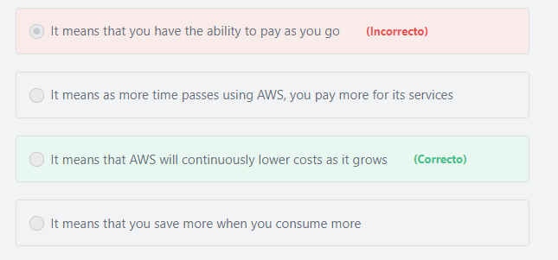

Final del formulario

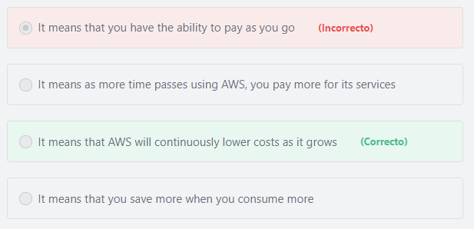Principio del formulario

**Explicación**

                 By using cloud computing, you can achieve a lower variable cost than you would get on your own. Because usage from hundreds of thousands of customers is aggregated in the cloud, providers such as AWS can achieve higher economies of scale, which translates into lower pay as-you-go prices. For example, AWS has reduced the per GB storage price of S3 by 80% since the service was first introduced in 2006.

***The other options are incorrect:***

***"It means that you save more when you consume more" is incorrect.***It is correct that you can save more by using more but this describes the AWS tiered pricing not “Economies of scale”.

***"It means that you have the ability to pay as you go" is incorrect.***It is correct that AWS gives you the ability to pay as you go so you can increase or decrease your spending as your company’s requirements change, but this does not describe “Economies of scale”.

***"It means as more time passes using AWS, you pay more for its services" is incorrect.***This statement should be “The more time passes using AWS, the less you pay for its services”. This corrected statement now describes “Economies of scale”. AWS Economies of Scale refers to the discounts that you get over time as AWS grows.

**References:**

<https://docs.aws.amazon.com/aws-technical-content/latest/aws-overview/six-advantages-of-cloud-computing.html>

Final del formulario

Principio del formulario

Pregunta 21:**Incorrecto**

**For Amazon RDS databases, what does AWS perform on your behalf? (Choose TWO)**

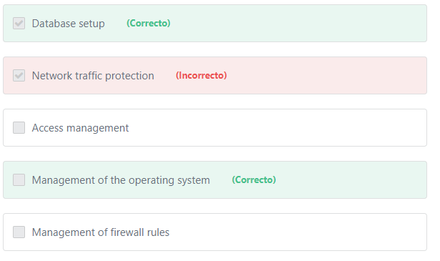

Final del formulario

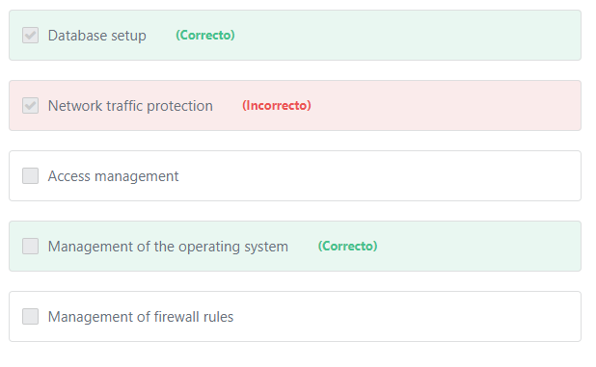Principio del formulario

**Explicación**

In relation to Amazon RDS databases:

AWS is responsible for:

1- Managing the underlying infrastructure and foundation services.

2- Managing the operating system.

3- Database setup.

4- Patching and backups.

The customer is still responsible for:

1- Protecting the data stored in databases (through encryption and IAM access control).

2- Managing the database settings that are specific to the application.

3- Building the relational schema.

4- Network traffic protection.

***The other options are incorrect:***

***"Access management "is incorrect.*** The customer is responsible for managing access to all AWS services and resources.

***"Management of firewall rules" is incorrect.*** The customer is responsible for managing firewall rules using security groups.

***"Network traffic protection" is incorrect.***The customer is responsible for protecting network traffic using security groups, NACLs and AWS WAFs.

**References:**

<https://docs.aws.amazon.com/AmazonRDS/latest/UserGuide/UsingWithRDS.html>

Final del formulario

Principio del formulario

Pregunta 22:**Incorrecto**

**The owner of an E-Commerce application notices that the compute capacity requirements vary heavily from time to time. What makes AWS more economical than traditional data centers for this type of application?**

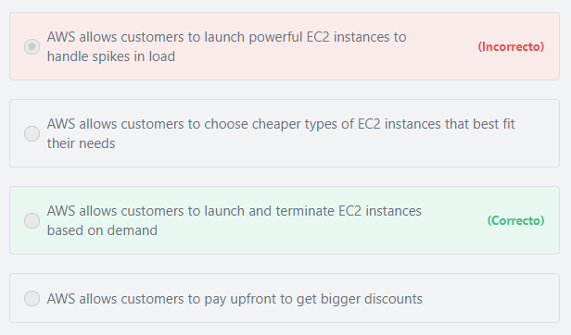

Final del formulario

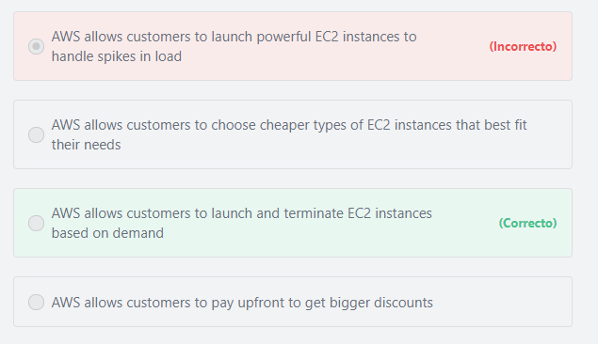Principio del formulario

**Explicación**

           On-Demand Instances have no contract commitment and can be launched (or terminated) as needed. You are charged by the second based on an hourly rate and you pay only for what you use. This makes them ideal for applications with short-term or irregular workloads.

***The other options are incorrect:***

***"AWS allows customers to choose cheaper types of EC2 instances that best fit their needs" is incorrect.***In this example, the problem is not a matter of choosing the right instance type, the problem is that their application faces spikes in load.

Additional information:

AWS allows customers to choose from various types of EC2 Instances. Instance types comprise of various combinations of CPU, memory, storage, and networking capacity and give you the flexibility to choose the appropriate mix of resources for your applications.

***"AWS allows customers to launch powerful EC2 instances to handle spikes in load" is incorrect.***  Provisioning powerful EC2 instances can handle spikes in load, but when the demand decreases you will still pay for those running instances.

Additional information:

       Choosing the right instance type depends on your application’s needs. In some cases, multiple small EC2 instances running in parallel can be more powerful and more economical than one large instance. For example, if a customer wants to transcode a large number of video files, AWS recommends using multiple small EC2 instances in parallel. If one instance is interrupted, the other instances can still complete their jobs.

***"AWS allows customers to pay upfront to get bigger discounts" is incorrect.***Paying upfront to get more discounts is possible using Reserved Instances. But this option is suitable only for applications that have a steady usage forecast for a period of a year or more.

**References:**

<https://aws.amazon.com/ec2/pricing/on-demand/>

Final del formulario

Principio del formulario

Pregunta 23:**Incorrecto**

**You have a real-time IoT application that requires sub-millisecond latency. Which of the following services should you use?**

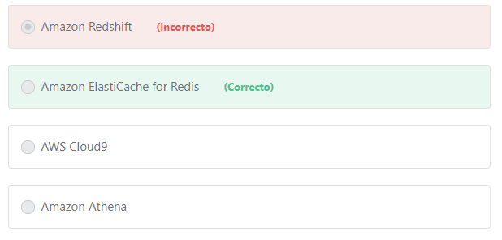

Final del formulario

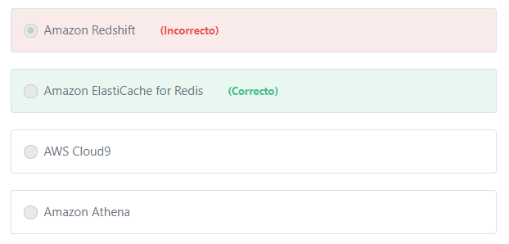Principio del formulario

**Explicación**

              Amazon ElastiCache for Redis is a blazing fast in-memory data store that provides sub-millisecond latency to power internet-scale real-time applications. Built on open-source Redis and compatible with the Redis APIs, ElastiCache for Redis works with your Redis clients and uses the open Redis data format to store your data. Your self-managed Redis applications can work seamlessly with ElastiCache for Redis without any code changes. ElastiCache for Redis combines the speed, simplicity, and versatility of open-source Redis with manageability, security, and scalability from Amazon to power the most demanding real-time applications in Gaming, Ad-Tech, E-Commerce, Healthcare, Financial Services, and IoT.

***The other options are incorrect:***

***"AWS Cloud9" is incorrect.***AWS Cloud9 is a cloud-based integrated development environment (IDE) that lets you write, run, and debug your code with just a browser.

***Amazon Redshift is incorrect.*** Amazon Redshift is a data warehouse service.

***"Amazon Athena" is incorrect.***Amazon Athena is an interactive query service that makes it easy to analyze data in Amazon S3 using standard SQL.

**References:**

<https://aws.amazon.com/elasticache/redis/>

Final del formulario

Principio del formulario

Pregunta 24:**Correcto**

**Which statement best describes the AWS Pay-As-You-Go pricing model?**

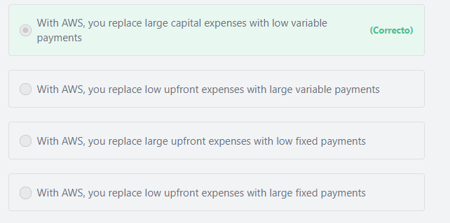

Final del formulario

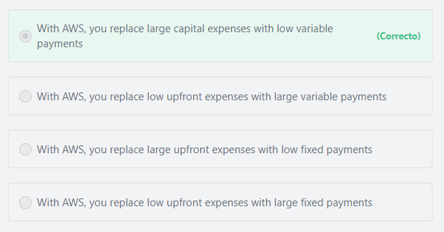Principio del formulario

**Explicación**

             AWS does not require minimum spend commitments or long-term contracts. You replace large fixed upfront expenses with low variable payments that only apply based on what you use. For example, when using On-demand instances you pay only for the hours\seconds they are running and nothing more.

**References:**

<https://aws.amazon.com/pricing/>

Final del formulario

Principio del formulario

Pregunta 25:**Incorrecto**

**Amazon EBS volumes can be attached to which of the following compute resources?**

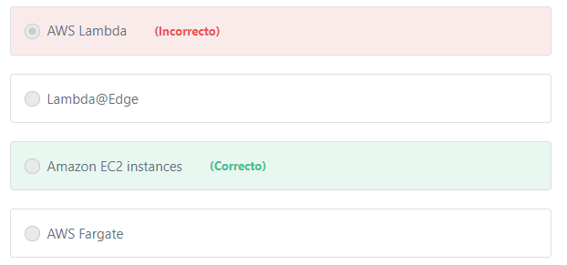

Final del formulario

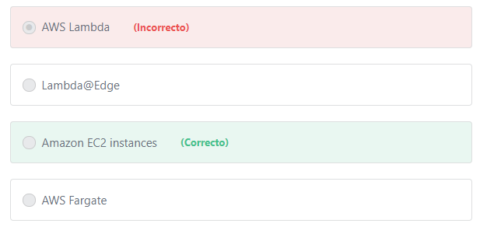Principio del formulario

**Explicación**

        An Amazon EBS volume is a durable, block-level storage device that can be attached to a single EC2 instance. You can use EBS volumes as primary storage for data that requires frequent updates, such as the system drive for an instance or storage for database software.

***The other options are incorrect:***

***"AWS Lambda" is incorrect.***AWS Lambda is a serverless compute service. You cannot attach EBS volumes to Lambda.

***"AWS Fargate" is incorrect.***AWS Fargate is a serverless compute engine for containers. You cannot attach EBS volumes to Fargate.

***"Lambda@Edge" is incorrect.***Lambda@Edge is a feature of Amazon CloudFront that lets you run code closer to users of your application, which improves performance and reduces latency. You cannot attach EBS volumes to Lambda@Edge.

**References:**

<https://docs.aws.amazon.com/AWSEC2/latest/UserGuide/EBSVolumes.html>

Final del formulario

Principio del formulario

Pregunta 26:**Incorrecto**

**Which of the following compute resources are serverless? (Choose TWO)**

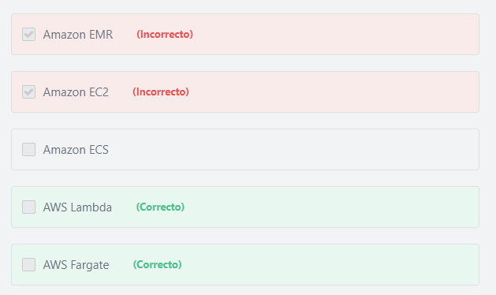

Final del formulario

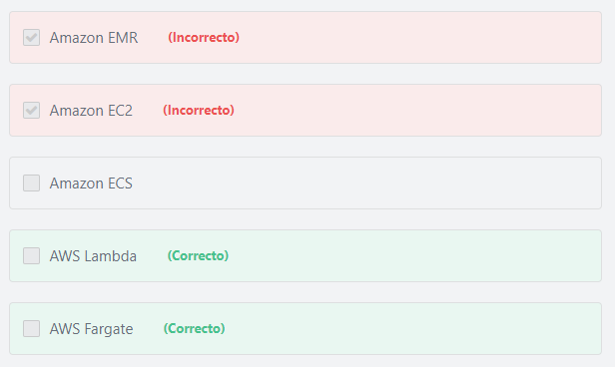Principio del formulario

**Explicación**

         AWS Lambda lets you run code without provisioning or managing servers. You pay only for the compute time you consume, and there is no charge when your code is not running. With Lambda, you can run code for virtually any type of application or backend service - all with zero administration. Just upload your code and Lambda takes care of everything required to run and scale your code with high availability.

         AWS Fargate is a compute engine for deploying and managing containers, which frees you from having to manage any of the underlying infrastructure. With AWS Fargate, you no longer have to provision, configure, and scale clusters of virtual machines to run containers. AWS Fargate seamlessly integrates with Amazon ECS, so you can deploy and manage containers without having to provision or manage servers.

***The other options are incorrect:***

***Amazon EC2 is incorrect.*** Amazon EC2 provides its compute capacity through instances (servers).

***Amazon EMR is incorrect.***Amazon EMR is not serverless. Amazon EMR uses Amazon EC2 to process data at any scale.

***Amazon ECS is incorrect.*** Amazon ECS has two modes: Fargate launch type (serverless) and EC2 launch type (server-based). The Fargate launch type allows you to run containers without having to manage servers or clusters. The EC2 launch type allows you to have server-level, more granular control over the infrastructure that runs your container applications.

**References:**

<https://aws.amazon.com/lambda/>

<https://aws.amazon.com/fargate/>

Final del formulario

Principio del formulario

Pregunta 27:**Incorrecto**

**Which DynamoDB feature can be used to reduce the latency of requests to a database from milliseconds to microseconds?**

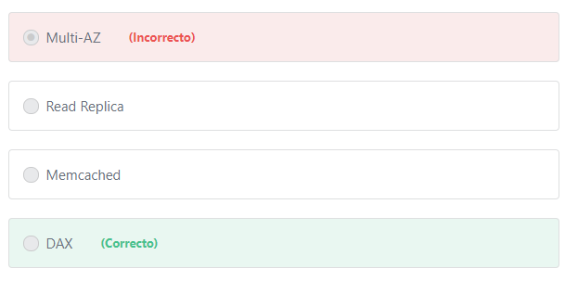

Final del formulario

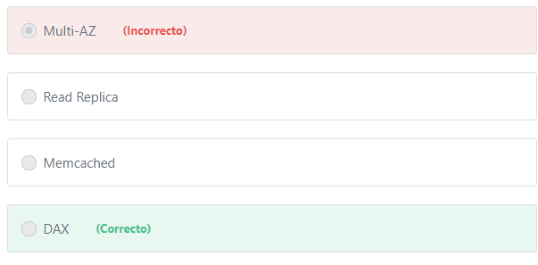Principio del formulario

**Explicación**

             Amazon DynamoDB Accelerator (DAX) is a fully managed, highly available, in-memory cache for DynamoDB that delivers performance improvements from milliseconds to microseconds – even at millions of requests per second. DAX adds in-memory acceleration to your DynamoDB tables without requiring you to manage cache invalidation, data population, or cluster management.

***The other options are incorrect:***

***"Multi-AZ" and "Read Replica" are incorrect.***Multi-AZ and Read Replica are Amazon RDS features.

***Memcached is incorrect.***Memcached is an in-memory key-value store, originally intended for caching. The AWS offering for Memcached is Amazon ElastiCache, not DynamoDB.

**References:**

<https://aws.amazon.com/dynamodb/dax/>

Final del formulario

Principio del formulario

Pregunta 28:**Incorrecto**

**Which of the following is an available option when purchasing Amazon EC2 instances?**

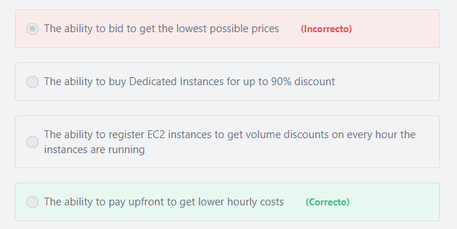

Final del formulario

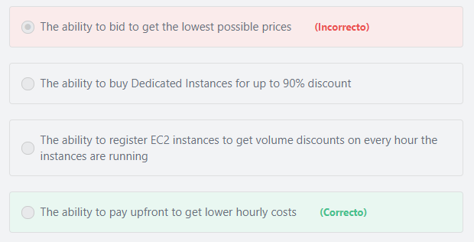Principio del formulario

**Explicación**

             With EC2 Reserved Instances, you can save up to 75% over equivalent on-demand compute capacity. When you buy Reserved Instances, the larger the upfront payment, the greater the discount.

***The other options are incorrect:***

***"The ability to bid to get the lowest possible prices" is incorrect.***AWS has eliminated "bidding" in the new AWS Spot instance pricing model. The way the new pricing model works is that you just pay the Spot price that’s in effect for the current hour for the instances that you launch. It’s that simple. Now you can request Spot capacity just like you would request On-Demand capacity, without having to spend time analyzing market prices or setting a bid price. In the new model, the Spot prices are more predictable, updated less frequently, and are determined by the long-term supply and demand for Amazon EC2 spare capacity, not bid prices. Your Spot Instance runs whenever capacity is available and the maximum price per hour for your request exceeds the Spot price.

An example to illustrate: If the current AWS Spot price is $0.08 per hour and you set a maximum price of $0.17, you’ll pay $0.08 and you will lose the instances if the AWS Spot price rises above $0.17 or if capacity is no longer available.

***"The ability to buy Dedicated Instances for up to 90% discount" is incorrect.***The Amazon EC2 purchase option that provides up to 90% discount is Amazon EC2 Spot Instances.

***"The ability to register EC2 instances to get volume discounts on every hour the instances are running" is incorrect.***Volume-based discounting is a method by which the prices of units bought are lowered when large quantities are purchased. Volume Pricing or Tiered Pricing is not applied to EC2 hourly charges. Volume pricing is available only for storage and data transfer. The more storage and data transfer you use, the less you pay per gigabyte.

**References:**

<https://aws.amazon.com/ec2/pricing/reserved-instances/>

Final del formulario

Principio del formulario

Pregunta 29:**Correcto**

**Your application requirements for CPU and RAM are changing in an unpredictable way. Which service can be used to dynamically adjust these resources based on load?**

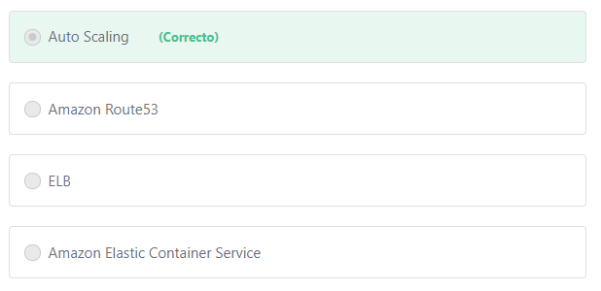

Final del formulario

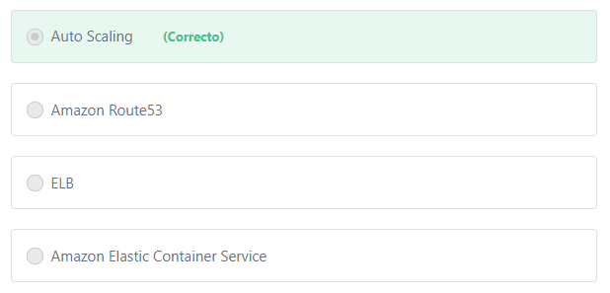Principio del formulario

**Explicación**

             The AWS Auto Scaling service allows you to automatically provision new resources to meet demand and maintain performance. When demand decreases, Auto Scaling shuts down unused resources automatically to reduce costs.

***The other options are incorrect:***

***ELB is incorrect.***Elastic Load Balancing (ELB) is used to distribute traffic automatically across multiple targets, such as Amazon EC2 instances, containers, IP addresses, and Lambda functions.

***Amazon Route53 is incorrect.*** Amazon Route 53 is a highly available and scalable cloud Domain Name System (DNS) web service.

***Amazon Elastic Container Service is incorrect.***Amazon Elastic Container Service is used to run containerized applications in AWS.

**References:**

<https://d1.awsstatic.com/whitepapers/aws-overview.pdf>

Final del formulario

Principio del formulario

Pregunta 30:**Incorrecto**

**To protect against data loss, you need to backup your database regularly. What is the most cost-effective storage option that provides immediate retrieval of your backups?**

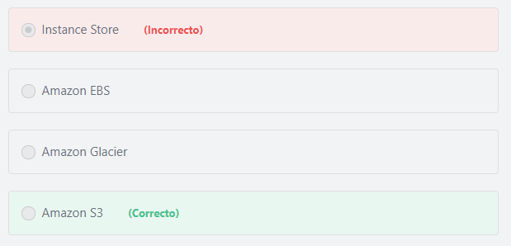

Final del formulario

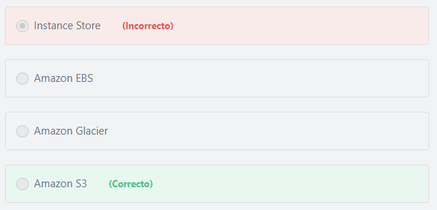Principio del formulario

**Explicación**

               Database backup is an important operation to consider for any database system. Taking backups not only enables data restore on database failure but also enables recovery from data corruption. Amazon S3 provides highly durable and reliable storage for database backups while reducing costs. Data stored in Amazon S3 can be retrieved immediately when needed.

***The other options are incorrect:***

***Amazon Glacier is incorrect.***Amazon Glacier does not provide immediate retrieval. Amazon Glacier provides three options to retrieve your data with retrieval times ranging from a few minutes to several hours. Amazon Glacier is a low-cost S3 storage class  for data archiving.

***Amazon EBS is incorrect.***Amazon EBS is not a cost effective-choice compared to S3 in this use case.

***Instance Store is incorrect.*** Instance Store can only be used to store temporary data such as buffers, caches, scratch data, and other temporary content. You cannot rely on instance store for valuable, long-term data because data in the instance store is lost if the instance stops, terminates or if the underlying disk drive fails.

**References:**

<https://aws.amazon.com/s3/>

Final del formulario

Principio del formulario

Pregunta 31:**Incorrecto**

**Which of the following is not an AWS reservation model?**

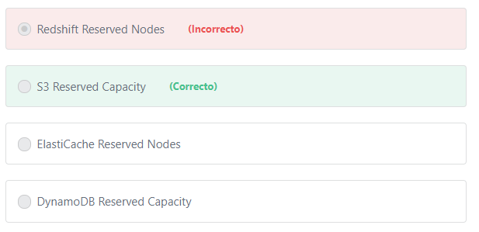

Final del formulario

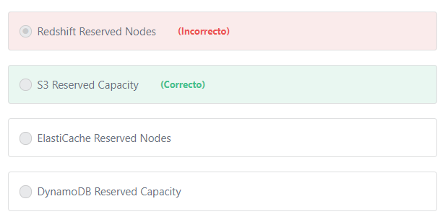Principio del formulario

**Explicación**

There are no reservations in S3. You pay for what you use.

              While the cloud is well-suited for running variable workloads and rapid deployments, many cloud-based workloads display a more predictable pattern. For these stable applications, organizations can achieve significant cost savings by taking advantage of the available reservation models such as EC2 reserved instances, RDS reserved instances, ElastiCache Reserved Nodes, DynamoDB Reserved Capacity and Redshift Reserved Nodes.

References:

<https://aws.amazon.com/s3/pricing/>

<https://d1.awsstatic.com/whitepapers/aws_pricing_overview.pdf>

Final del formulario

Principio del formulario

Pregunta 32:**Incorrecto**

**What best describes penetration testing?**

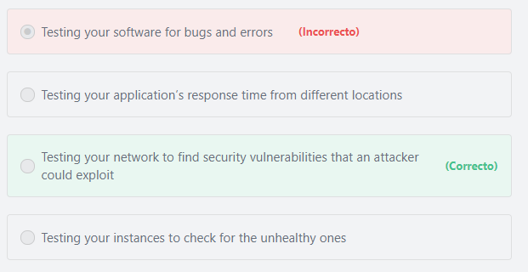

Final del formulario

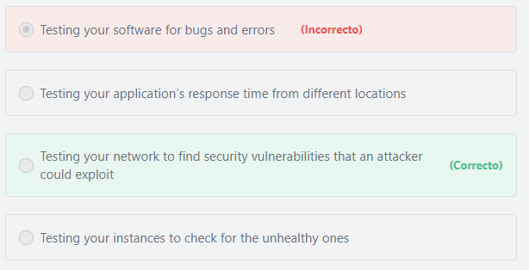Principio del formulario

**Explicación**

Penetration testing is the practice of testing a network or web application to find security vulnerabilities that an attacker could exploit.

**References:**

<https://aws.amazon.com/security/penetration-testing/>

Final del formulario

Principio del formulario

Pregunta 33:**Incorrecto**

**You are using several on-demand EC2 Instances to run your development environment. What is the best way to reduce your charges when these instances are not in use?**

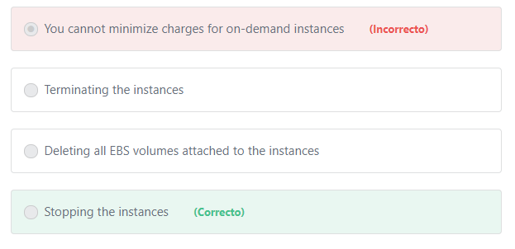

Final del formulario

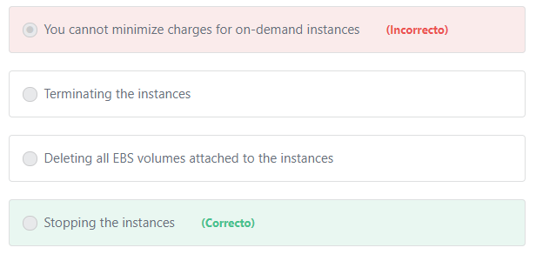Principio del formulario

**Explicación**

        AWS doesn't charge usage for a stopped instance, or data transfer fees. For a stopped instance AWS will only charge you for EBS storage volumes attached to the instances.

***The other options are incorrect:***

***"Deleting all EBS volumes attached to the instances" is incorrect.***This option is incorrect because you will lose the data on the EBS volumes in your development environment.

***"Terminating the instances" is incorrect.*** If you terminate the instances without taking an image (AMI) of them, you will lose their data.

***"You cannot minimize charges for on-demand instances" is incorrect.*** You can minimize charges by stopping the instances when you do not need them.

**References:**

<https://aws.amazon.com/ec2/pricing/on-demand/>

Final del formulario

Principio del formulario

Pregunta 34:**Incorrecto**

**Your web application currently faces performance issues and suffers from long load times. Which of the following AWS services could help fix these issues and improve performance?**

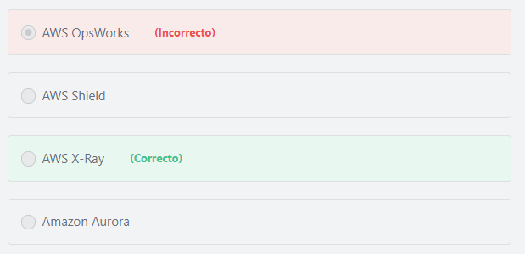

Final del formulario

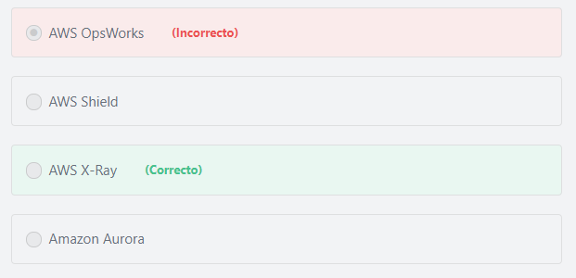Principio del formulario

**Explicación**

             AWS X-Ray helps you identify performance bottlenecks. X-Ray’s service maps let you see relationships between services and resources in your application in real time. You can easily detect where high latencies are occurring, visualize node and edge latency distribution for services, and then drill down into the specific services and paths impacting application performance.

***The other options are incorrect:***

***AWS OpsWorks is incorrect.*** AWS OpsWorks is used to automate operations with Chef and Puppet.

***AWS Shield is incorrect.***AWS Shield is a managed Distributed Denial of Service (DDoS) protection service that safeguards applications running on AWS. AWS Shield Standard is automatically enabled to all AWS customers and provides always-on detection and automatic inline mitigations that minimize application downtime and latency.

***Amazon Aurora is incorrect.***Amazon Aurora is a database service.

**References:**

<https://aws.amazon.com/xray/>

Final del formulario

Principio del formulario

Pregunta 35:**Incorrecto**

**Which of the following are valid Amazon EC2 Reserved Instance types? (Choose TWO)**

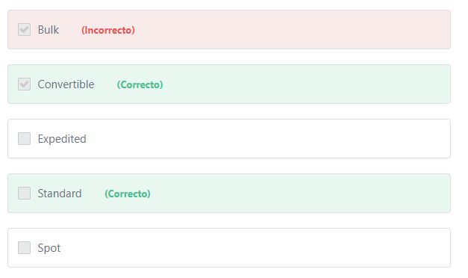

Final del formulario

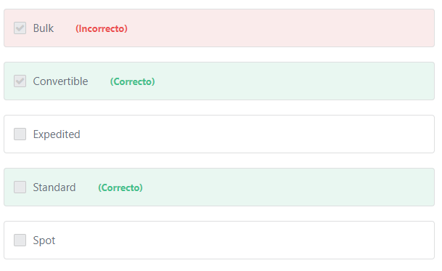Principio del formulario

**Explicación**

             There are three types of EC2 Reserved Instances(RIs) that you can choose from based on your applications needs:

1- Standard RIs: These provide the most significant discount (up to 75% off On-Demand) and are best suited for steady-state usage.

2- Convertible RIs: These provide a discount (up to 54% off On-Demand) and the capability to change the attributes of the RI as long as the exchange results in the creation of Reserved Instances of equal or greater value. Like Standard RIs, Convertible RIs are best suited for steady-state usage.

3- Scheduled RIs: These are available to launch within the time windows you reserve. This option allows you to match your capacity reservation to a predictable recurring schedule that only requires a fraction of a day, a week, or a month.

***The other options are incorrect:***

***Spot is incorrect.***Spot is a different Amazon EC2 payment option.

***Bulk and Expedited are incorrect.*** Bulk and Expedited are retrieval options for Amazon Glacier.

**References:**

<https://aws.amazon.com/ec2/pricing/reserved-instances/>

Final del formulario

Principio del formulario

Pregunta 36:**Incorrecto**

**Which AWS service collects metrics from running EC2 instances?**

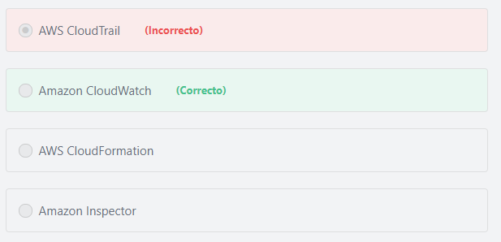

Final del formulario

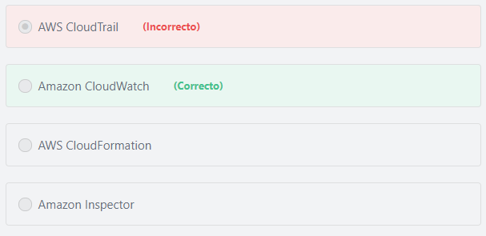Principio del formulario

**Explicación**

            Amazon CloudWatch is a monitoring service for AWS cloud resources and the applications you run on AWS. You can use Amazon CloudWatch to collect and track metrics, collect and monitor log files, set alarms, and automatically react to changes in your AWS resources.

***The other options are incorrect:***

***"AWS CloudTrail" is incorrect.*** CloudTrail logs all API calls made to AWS services with credentials linked to your accounts.

***"AWS CloudFormation" is incorrect.***AWS CloudFormation allows you to use a simple text file to model and provision, in an automated and secure manner, all the resources needed for your applications across all regions and accounts.

***"Amazon Inspector" is incorrect.***Amazon Inspector is an automated security assessment service that helps improve the security and compliance of applications deployed on AWS.

**References:**

<https://aws.amazon.com/cloudwatch>

Final del formulario

Principio del formulario

Pregunta 37:**Correcto**

**You are facing a lot of problems with your current contact center. Which service provides a cloud-based contact center that can deliver a better service for your customers?**

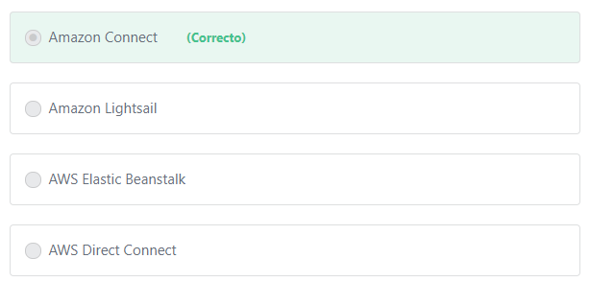

Final del formulario

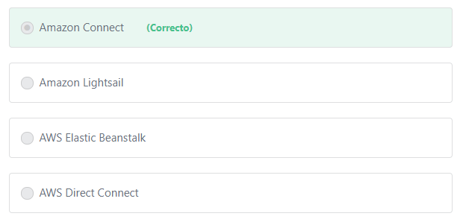Principio del formulario

**Explicación**

       Amazon Connect is a cloud-based contact center solution. Amazon Connect makes it easy to set up and manage a customer contact center and provide reliable customer engagement at any scale. You can set up a contact center in just a few steps, add agents from anywhere, and start to engage with your customers right away. Amazon Connect provides rich metrics and real-time reporting that allow you to optimize contact routing. You can also resolve customer issues more efficiently by putting customers in touch with the right agents. Amazon Connect integrates with your existing systems and business applications to provide visibility and insight into all of your customer interactions.

***The other options are incorrect:***

***Amazon Lightsail is incorrect.***Amazon Lightsail provides a low-cost Virtual Private Server (VPS) in the cloud.

***AWS Elastic Beanstalk is incorrect.***AWS Elastic Beanstalk makes it easier for developers to quickly deploy and manage applications in the AWS Cloud. Developers simply upload their application, and Elastic Beanstalk automatically handles the deployment details of capacity provisioning, load balancing, auto-scaling, and application health monitoring.

***AWS Direct Connect is incorrect.***AWS Direct Connect is a cloud service solution that makes it easy to establish a dedicated network connection from your premises to AWS. Using AWS Direct Connect, you can establish private connectivity between AWS and your datacenter, office, or colocation environment, which in many cases can reduce your network costs, increase bandwidth throughput, and provide a more consistent network experience than Internet-based connections.

**References:**

<https://aws.amazon.com/connect/>

Final del formulario

Principio del formulario

Pregunta 38:**Incorrecto**

**You have just set up your AWS environment and have created six IAM user accounts for the DevOps team. What is the AWS recommendation when granting permissions to these IAM accounts?**

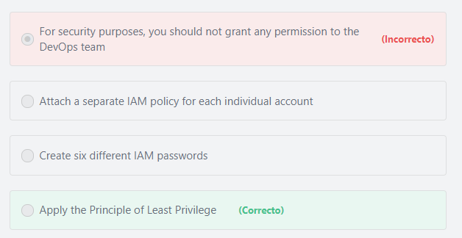

Final del formulario

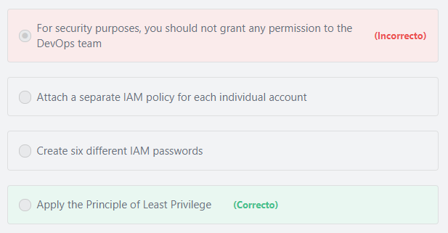Principio del formulario

**Explicación**

           The Principle of Least Privilege (PoLP, also known as the principle of minimal privilege or the principle of least authority) requires that in a particular abstraction layer of a computing environment, every module (such as a process, a user, or a program, depending on the subject) must be able to access only the information and resources that are necessary for its legitimate purpose. For example, a user account for the sole purpose of creating backups does not need to install software: hence, it has rights only to run backup and backup-related applications. Any other privileges, such as installing new software, are blocked.

***The other options are incorrect:***

***"For security purposes, you should not grant any permission to the DevOps team" is incorrect.*** Each user should have the necessary permissions to do his assigned job. This will not impact the security of your account (if done correctly).

***"Attach a separate IAM policy for each individual account" is incorrect.*** It is recommended to create an IAM group for each team and attach the required policies to the group. This way, if there is a change, you can simply apply it to that group not the individual accounts.

***"Create six different IAM passwords" is incorrect.*** Passwords are not related to granting permissions. User names and passwords are used to authenticate users when logging into the AWS management console.

**References:**

<https://docs.aws.amazon.com/IAM/latest/UserGuide/best-practices.html#grant-least-privilege>

Final del formulario

Principio del formulario

Pregunta 39:**Incorrecto**

**Why are Serverless Architectures more economical than Server-based Architectures?**

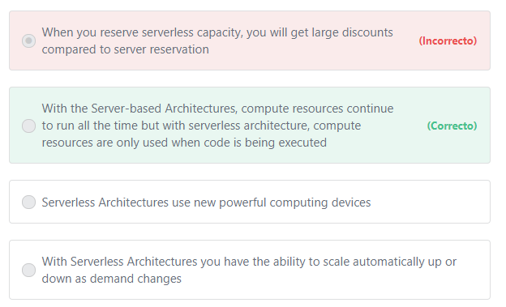

Final del formulario

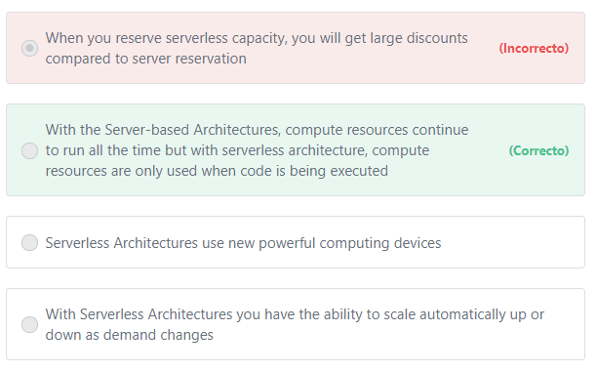Principio del formulario

**Explicación**

           Serverless architectures can reduce costs because you do not have to manage or pay for underutilized servers, or provision redundant infrastructure to implement high availability. For example, you can upload your code to the AWS Lambda compute service, and the service can run the code on your behalf using AWS infrastructure. With AWS Lambda, you are charged for every 100ms your code executes and the number of times your code is triggered.

***The other options are incorrect:***

***"Serverless Architectures use new powerful computing devices" is incorrect.***AWS uses the same devices for both server-based and serverless architectures.

***"With Serverless Architectures you have the ability to scale automatically up or down as demand changes" is incorrect.*** With Serverless Architecture, you do not have to worry about scaling compute capacity. AWS handles that for you.

***"When you reserve serverless capacity, you will get large discounts compared to server reservation" is incorrect.*** There are no reservations when using Serverless Architectures.

**References:**

<https://aws.amazon.com/serverless/>

Final del formulario

Principio del formulario

Pregunta 40:**Incorrecto**

**Which of the following strategies helps protect your AWS root account?**

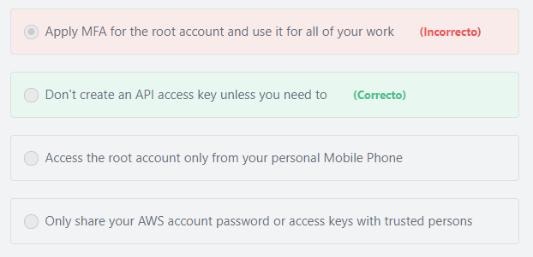

Final del formulario

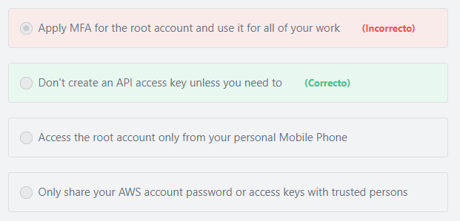Principio del formulario

**Explicación**

            Anyone who has root user access keys for your AWS account has unrestricted access to all the resources in your account, including billing information. If you don't already have an access key for your AWS account root user, don't create one unless you absolutely need to. If you do have an access key for your AWS account root user, delete it. If you must keep it, rotate (change) the access key regularly.

***The other options are incorrect:***

***"Access the root account only from your personal Mobile Phone" is incorrect.***You can access your root account from any supported device, but make sure that no one else can access these devices or monitor them.

***"Only share your AWS account password or access keys with trusted persons" is incorrect.*** You should never share your AWS account password or access keys with anyone. Instead, create individual named users for anyone who needs access to your AWS account. By creating individual IAM users for people accessing your account, you can give each IAM user a unique set of security credentials. You can also grant different permissions to each IAM user. If necessary, you can change or revoke an IAM user's permissions any time. (If you give out your root user credentials, it can be difficult to revoke them, and it is impossible to restrict their permissions.).

**Additional information:**

Instead of defining permissions for individual IAM users, it's usually more convenient to create groups that relate to job functions (administrators, developers, accounting, etc.). Next, define the relevant permissions for each group. Finally, assign IAM users to those groups. All the users in an IAM group inherit the permissions assigned to the group. That way, you can make changes for everyone in a group in just one place. As people move around in your company, you can simply change what IAM group their IAM user belongs to.

***"Apply MFA for the root account and use it for all of your work" is incorrect.***AWS strongly recommends that you do not use the AWS account root user for day-to-day tasks, even administrative tasks. Instead, use the root user to create your first IAM user, then use this instead. Securely lock away the root user credentials and only use them for tasks that require root access.

**References:**

<https://docs.aws.amazon.com/IAM/latest/UserGuide/best-practices.html>

Final del formulario

Principio del formulario

Pregunta 41:**Incorrecto**

**What is the main benefit of the AWS Storage Gateway service?**

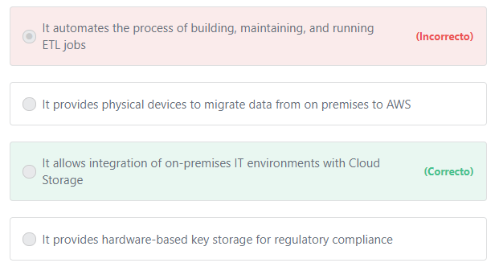

Final del formulario

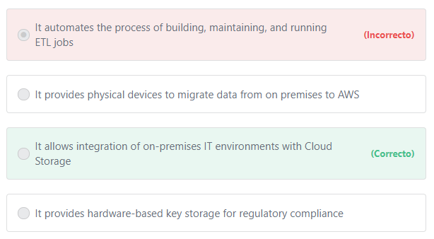Principio del formulario

**Explicación**

           AWS Storage Gateway connects an on-premises software appliance with cloud-based storage to provide seamless integration with data security features between your on-premises IT environment and the AWS storage infrastructure.

***The other options are incorrect:***

***"It automates the process of building, maintaining, and running ETL jobs" is incorrect.*** AWS Storage Gateway is not used for building and running ETL jobs. The name of the service that performs this function is AWS Glue.

          ETL stands for “Extract, Transform, and Load” which is the process of collecting data from various sources (from different databases for example), transform the data depending on business rules/needs (This step helps in preparing the data for analytics and decision making) and load the data into a destination database, often a data warehouse.

         AWS Glue is a fully-managed, Extract, Transform, and Load (ETL) service that automates the time-consuming steps of data preparation for analytics. AWS Glue crawls your data sources, identifies data formats, and suggests schemas and transformations. After transforming the data, AWS Glue loads the data into your data warehouse or data lake for regular reporting and analysis. By storing data in a data warehouse or data lake, you integrate information from different parts of your business and provide a common source of data for decision making.

***"It provides physical devices to migrate data from on premises to AWS" is not correct.***AWS Storage Gateway does not provide physical devices to migrate data from on premises to AWS. The name of the service that performs this function is AWS Snowball.

***"It provides hardware-based key storage for regulatory compliance" is incorrect.***AWS Storage Gateway does not provide hardware-based key storage. The name of the service that performs this function is AWS CloudHSM.

        The AWS CloudHSM service helps you meet corporate, contractual, and regulatory compliance requirements for data security by using dedicated Hardware Security Module (HSM) instances within the AWS cloud. AWS and AWS Marketplace partners offer a variety of solutions for protecting sensitive data within the AWS platform, but for some applications and data subject to contractual or regulatory mandates for managing cryptographic keys, additional protection may be necessary. CloudHSM complements existing data protection solutions and allows you to protect your encryption keys within HSMs that are designed and validated to government standards for secure key management. HSM is a piece of hardware — a dedicated appliance that provides secure key storage and a set of cryptographic operations within a tamper-resistant enclosure. CloudHSM allows you to securely generate, store, and manage cryptographic keys used for data encryption in a way that keys are accessible only by you.

**References:**

<https://docs.aws.amazon.com/storagegateway/latest/userguide/WhatIsStorageGateway.html>

Final del formulario

Principio del formulario

Pregunta 42:**Correcto**

**Which of the following is a feature of Amazon RDS that performs automatic failover when the primary database fails to respond?**

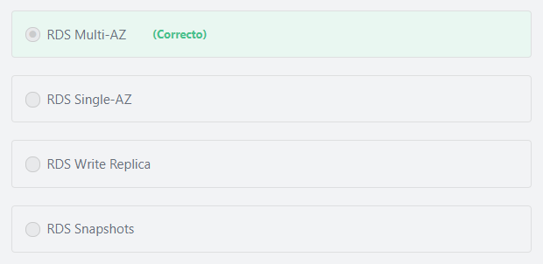

Final del formulario

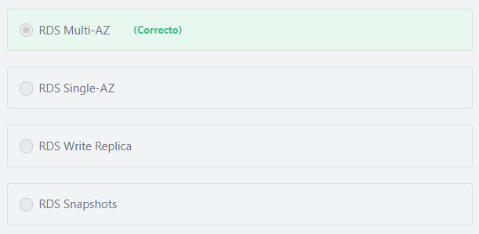Principio del formulario

**Explicación**

           When you enable Multi-AZ, Amazon Relational Database Service (Amazon RDS) maintains a redundant and consistent standby copy of your data. If you encounter problems with the primary copy, Amazon RDS automatically switches to the standby copy (or to a read replica in the case of Amazon Aurora) to provide continued availability to the data. The two copies are maintained in different Availability Zones (AZs), hence the name “Multi-AZ.” Each AZ runs on its own physically distinct, independent infrastructure, and is engineered to be highly reliable. Having separate Availability Zones greatly reduces the likelihood that both copies will concurrently be affected by most types of disturbances.

***The other options are incorrect:***

***"RDS Snapshots" is incorrect.***RDS snapshots are user-initiated backups of your instance.

***"RDS Write Replica" is incorrect.*** The name of this feature is RDS Read Replica, not RDS Write Replica. Amazon RDS can be configured to use Read Replicas to scale out beyond the capacity constraints of a single DB instance for read-heavy database workloads.

***"RDS Single-AZ" is incorrect.*** RDS Single-AZ is not an Amazon RDS feature.

**References:**

<https://aws.amazon.com/rds/details/multi-az/>

Final del formulario

Principio del formulario

Pregunta 43:**Incorrecto**

**For compliance and regulatory purposes, a government agency requires that their applications must run on hardware that is dedicated to them only. How can you meet this requirement?**

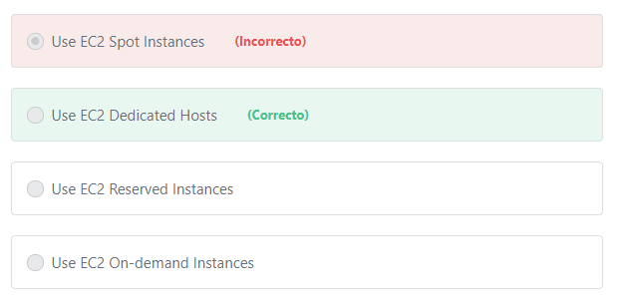

Final del formulario

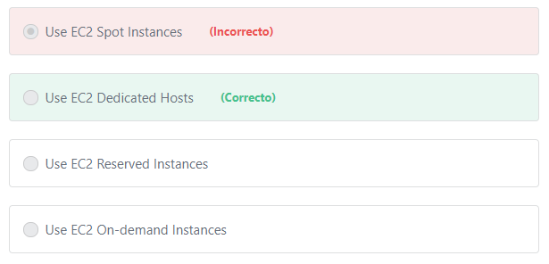Principio del formulario

**Explicación**

           When you launch instances on a Dedicated Host, the instances run on a physical server that is dedicated for your use. While Dedicated instances also run on dedicated hardware, Dedicated Hosts provide further visibility and control by allowing you to place your instances on a specific, physical server. This enables you to deploy instances using configurations that help address corporate compliance and regulatory requirements.

Note:

Amazon EC2 purchasing options include: On-Demand, Savings Plans, Reserved Instances, Spot Instances, Dedicated Hosts and Dedicated instances.

             Dedicated Instances also provides Hardware isolation. Dedicated Instances are Amazon EC2 instances that run in a virtual private cloud (VPC) on hardware that's dedicated to a single customer. Your Dedicated instances are physically isolated at the host hardware level from instances that belong to other AWS accounts. However, Dedicated Instances may share hardware with other instances from the same AWS account that are not Dedicated Instances.

The difference between *Dedicated Hosts and Dedicated Instances:*

1- Dedicated Instances guarantee that the instances will run on hardware that's dedicated to a single AWS account. But, as we mentioned above, Dedicated Instances may share hardware with other instances from the same AWS account that are not Dedicated Instances. That is not the case with Dedicated Hosts. Dedicated Hosts allow you to control how instances are placed on a specific physical server, and you can consistently deploy your instances to the same physical server over time. For that reason, Dedicated Hosts is a better option to handle compliance and regulatory requirements in most scenarios.

2- Dedicated Hosts enable you to benefit from the Bring Your Own License (BYOL) model for almost every BYOL scenario, while only certain scenarios are supported by Dedicated Instances. The BYOL model enables AWS customers to use their **existing** server-bound software licenses, including Windows Server, SQL Server, and SUSE Linux Enterprise Server. Dedicated Hosts provide additional control over your instances and visibility into Host level resources and tooling that allows you to manage software that consumes licenses on a per-core or per-socket basis, such as Windows Server and SQL Server. This is why most BYOL scenarios are supported through the use of Dedicated Hosts, while only certain scenarios are supported by Dedicated Instances.

***The other options are incorrect:***

Spot, Reserved and On-demand Instances do not provide physical isolation for EC2 instances.

**References:**

<https://www.amazonaws.cn/en/ec2/dedicated-hosts/>

Final del formulario

Principio del formulario

Pregunta 44:**Incorrecto**

**Which of the following are factors should be considered for Amazon EBS pricing? (Choose TWO)**

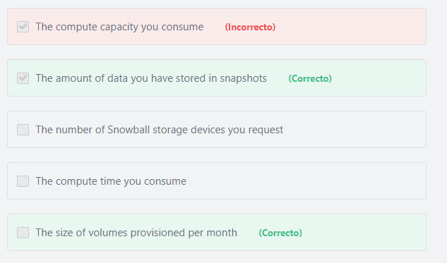

Final del formulario

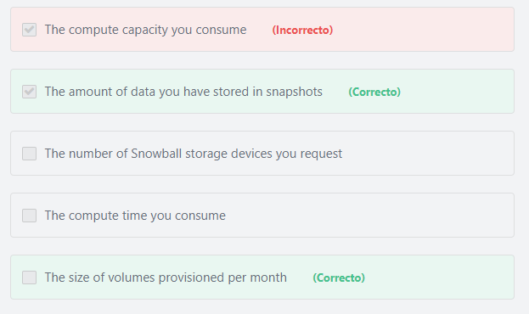Principio del formulario

**Explicación**

Amazon EBS pricing has two factors:

1- Volumes: Volume storage for all EBS volume types is charged by the amount of GB you provision per month, until you release the storage.

2- Snapshots: Snapshot storage is based on the amount of space your data consumes in Amazon S3. Because Amazon EBS does not save empty blocks, it is likely that the snapshot size will be considerably less than your volume size. Copying EBS snapshots is charged based on the volume of data transferred across regions. For the first snapshot of a volume, Amazon EBS saves a full copy of your data to Amazon S3. For each incremental snapshot, only the changed part of your Amazon EBS volume is saved. After the snapshot is copied, standard EBS snapshot charges apply for storage in the destination region.

***The other options are incorrect:***

***"The compute capacity you consume" and "The compute time you consume"are incorrect.*** Amazon EBS is not a compute service.

***"The number of Snowball storage devices you request" is incorrect.***There is no relation between Amazon EBS and AWS Snowball. AWS Snowball is a data transport solution that accelerates moving terabytes to petabytes of data into and out of AWS using storage devices designed to be secure for physical transport. Using Snowball helps to eliminate challenges that can be encountered with large-scale data transfers including high network costs, long transfer times, and security concerns.

**References:**

<https://d1.awsstatic.com/whitepapers/aws_pricing_overview.pdf>    page 10

Final del formulario

Principio del formulario

Pregunta 45:**Incorrecto**

**Select the services that are server-based: (Choose TWO)**

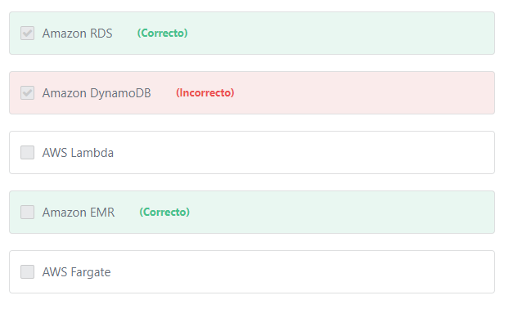

Final del formulario

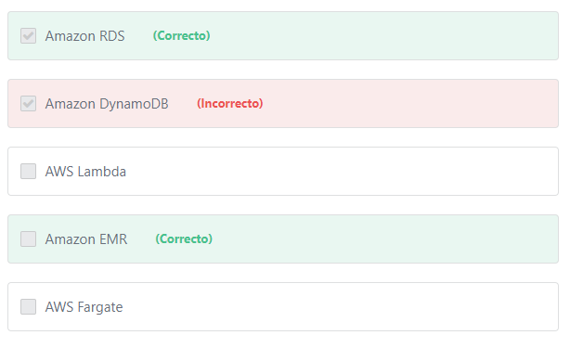Principio del formulario

**Explicación**

Server-based services include: Amazon EC2, Amazon RDS, Amazon Redshift and Amazon EMR.

Serverless services include: AWS Lambda, AWS Fargate, Amazon SNS, Amazon SQS and Amazon DynamoDB.

**References:**

<https://d1.awsstatic.com/whitepapers/aws-overview.pdf>

<https://aws.amazon.com/serverless/>

Final del formulario

Principio del formulario

Pregunta 46:**Incorrecto**

**Which of the following is a cloud computing deployment model that connects infrastructure and applications between cloud-based resources and existing resources not located in the cloud?**

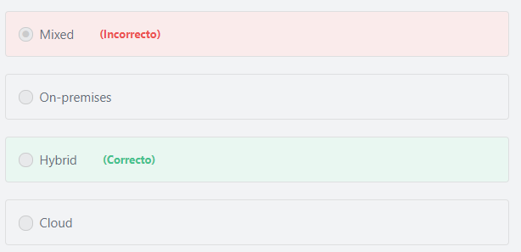

Final del formulario

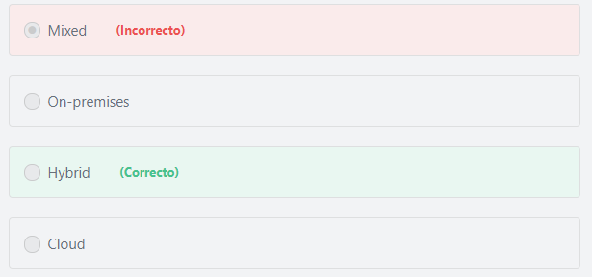Principio del formulario

**Explicación**

     A hybrid cloud model connects infrastructure and applications between cloud-based resources and existing resources that are not located in the cloud. The most common method of hybrid deployment is between the cloud and existing on-premises infrastructure to extend, and grow, an organization's infrastructure into the cloud while connecting cloud resources to internal systems.

***The other options are incorrect:***

***Cloud is incorrect.***A cloud-based application is fully deployed in the cloud and all parts of the application run in the cloud. Applications in the cloud have either been created in the cloud or have been migrated from an existing infrastructure to take advantage of the benefits of cloud computing. The most famous Cloud Computing providers are Amazon AWS, Microsoft Azure, and Google Cloud.

***On-premises is incorrect.*** An on-premises model is where an organization has their infrastructure and applications running in a datacenter that they own, or on hardware they are leasing from a third-party provider in their datacenter.

***Mixed is incorrect.***There are only three Cloud Computing deployment models: Cloud, Hybrid, and On-premises.

**References:**

<https://d1.awsstatic.com/whitepapers/aws-overview.pdf>

Final del formulario

Principio del formulario

Pregunta 47:**Incorrecto**

**Which statement is true in relation to the security of Amazon EC2?**

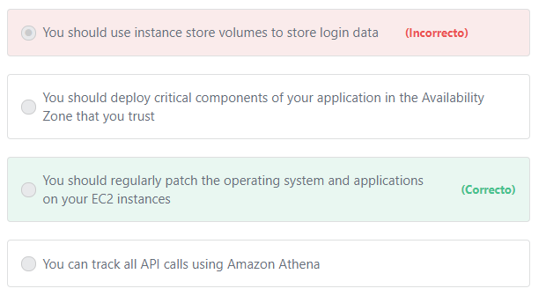

Final del formulario

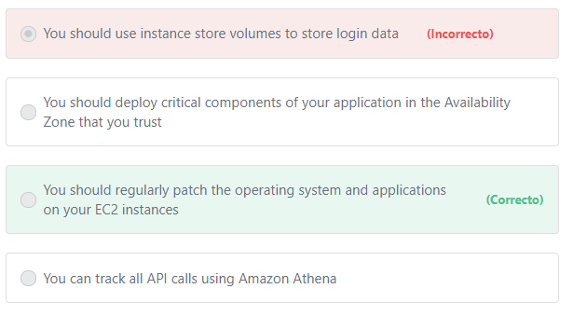Principio del formulario

**Explicación**

                Amazon EC2 is not a managed service, you should regularly patch, update, and secure the operating system and applications on your instance.

***The other options are incorrect:***

***"You can track all API calls using Amazon Athena" is incorrect.*** Amazon Athena is an interactive query service that enables you to analyze data in Amazon S3 using standard SQL.

***"You should deploy critical components of your application in the Availability Zone that you trust" is incorrect.*** All availability zones have the same level of security. They were designed using the same procedures and have the same characteristics. If you want to protect critical components of your application, you should enable data encryption at rest and in transit.

***"You should use instance store volumes to store login data" is incorrect.***An instance store provides temporary storage for your instance. Data stored in instance store volumes is not persistent (The data will be lost if the instance stops, is terminated, or when hardware fails). To store login data, you should use a persistent storage service such as EBS.

**References:**

<https://aws.amazon.com/compliance/shared-responsibility-model/>

<https://aws.amazon.com/ec2/>

Final del formulario

Principio del formulario

Pregunta 48:**Incorrecto**

**Which of the following AWS services would help you migrate on-premise databases to AWS?**

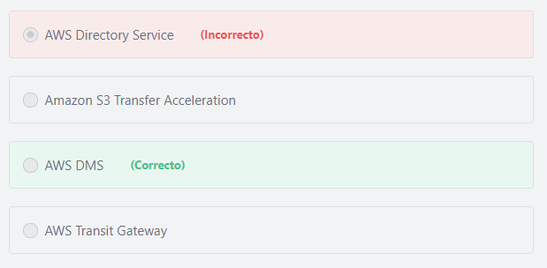

Final del formulario

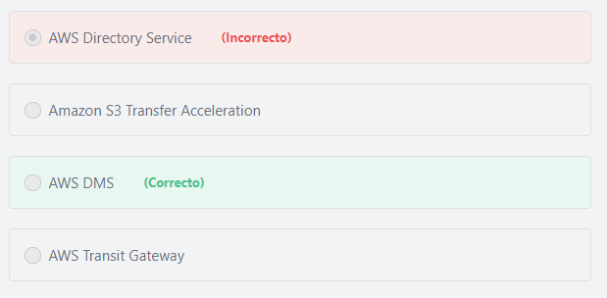Principio del formulario

**Explicación**

              AWS Database Migration Service helps you migrate databases to AWS quickly and securely. The source database remains fully operational during the migration, minimizing downtime to applications that rely on the database. The AWS Database Migration Service can migrate your data to and from most widely used commercial and open-source databases.

***The other options are incorrect:***

***AWS Directory Service is incorrect.***AWS Directory Service is a managed Microsoft Active Directory in the AWS Cloud. Customers can use it to manage users and groups, provide single sign-on (SSO) to applications and services, as well as create and apply group policies.

**Note:**What isSingle sign-on (SSO)? AWS Single sign-on (AWS SSO) enables a company’s employees to sign in to AWS using their existing corporate Microsoft Active Directory credentials.

***Amazon S3 Transfer Acceleration is incorrect.*** Amazon S3 Transfer Acceleration helps to read and write data to Amazon S3 over long geographic distances with low latency.

***AWS Transit Gateway is incorrect.*** AWS Transit Gateway is a network transit hub that customers can use to interconnect their virtual private clouds (VPCs) and their on-premises networks. AWS transit gateway simplifies how customers interconnect all of their VPCs, across thousands of AWS accounts and into their on-premises networks.

**References:**

<https://aws.amazon.com/dms/>

Final del formulario

Principio del formulario

Pregunta 49:**Incorrecto**

**Which of the following services gives you access to all AWS auditor-issued reports and certifications?**

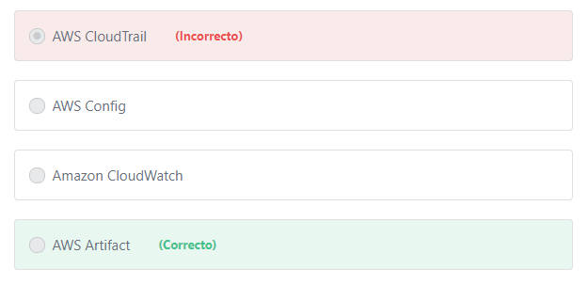

Final del formulario

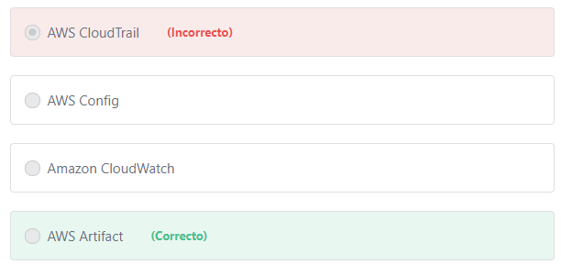Principio del formulario

**Explicación**

                 AWS Artifact is your go-to, central resource for compliance-related information that matters to you. It provides on-demand access to AWS’ security and compliance reports and select online agreements. Reports available in AWS Artifact include AWS Service Organization Control (SOC) reports, Payment Card Industry (PCI) reports, and certifications from accreditation bodies across geographies and compliance verticals that validate the implementation and operating effectiveness of AWS security controls. Agreements available in AWS Artifact include the Business Associate Addendum (BAA) and the Nondisclosure Agreement (NDA).

***The other options are incorrect:***

***"Amazon CloudWatch" is incorrect.*** Amazon CloudWatch is used to monitor AWS cloud resources.

***"AWS CloudTrail" is incorrect.***AWS CloudTrail is a service that provides visibility into user activity by logging all API calls related to your account. CloudTrail records important information about each API call, including who made the request, the services used, the actions performed, parameters for the actions, and the response elements returned by the AWS service. This information helps you to track changes made to your AWS resources and to troubleshoot operational issues.

***"AWS Config"*** ***is incorrect.***AWS Config is a fully managed service that provides you with an AWS resource inventory, configuration history, and configuration change notifications to help with compliance and governance. With AWS Config you can discover existing AWS resources, export a complete inventory of your AWS resources with all configuration details, and determine how a resource was configured at any point in time. These capabilities enable compliance auditing, security analysis, resource change tracking, and troubleshooting.

**References:**

<https://aws.amazon.com/artifact/>

Final del formulario

Principio del formulario

Pregunta 50:**Incorrecto**

**​ What are some key design principles for designing public cloud systems? (Choose TWO)**

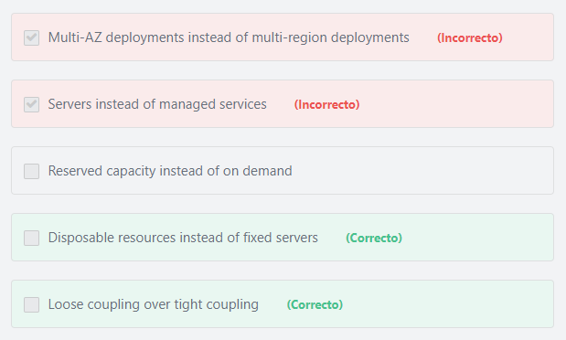

Final del formulario

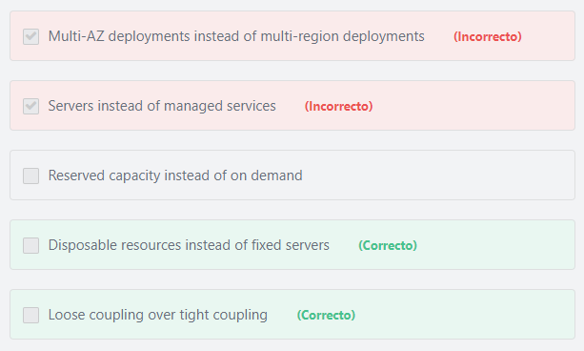Principio del formulario

**Explicación**

            The AWS Cloud includes many design patterns and architectural options that you can apply to a wide variety of use cases. Some key design principles of the AWS Cloud include scalability, disposable resources, automation, loose coupling, managed services instead of servers, and flexible data storage options.

**Disposable resources instead of fixed servers:**

When designing for the cloud, you can think of servers and other components as temporary resources that you can provision only when you need them instead of fixed servers that exist all the time. This approach solves many problems that usually appear in traditional, on-premises environments. For example, changes and software patches applied over time to the same (fixed) server can result in untested and heterogeneous configurations across different environments. You can solve this problem in AWS with an immutable infrastructure pattern. With this approach, if a problem happens with a server (EC2 instance), rather than updating, it is replaced with a new server containing the latest patches and configuration. This enables resources to always be in a consistent (and tested) state and makes rollbacks easier to perform.

**Loose coupling:**

Loose coupling is an approach that involves interconnecting the components in a system or network so that those components depend on each other to the least extent practical. Engineers should architect their systems and applications such that failure in one component does not negatively affect other components. Loosely coupled components make the system resilient and allow it to recover gracefully from failure.

***The other options are incorrect:***

***"Servers instead of managed services" is incorrect.***AWS recommend the use of managed services instead of servers where possible. AWS offers a broad set of compute, storage, database, analytics, application, and deployment services that help organizations move faster and lower IT costs. Architectures that do not leverage that breadth (e.g., if they use only Amazon EC2) might not be making the most of cloud computing and might be missing an opportunity to increase developer productivity and operational efficiency. AWS managed services provide building blocks that developers can consume to power their applications. These managed services include databases, machine learning, analytics, queuing, search, email, notifications, and more. For example, with Amazon SQS you can offload the administrative burden of operating a highly available, scalable messaging cluster, while paying a low price for only what you use. The same applies to Amazon S3, which enables you to store as much data as you want and access it when you need it, without having to think about capacity, hard disk configurations, replication, and other administrative issues.

***"Reserved capacity instead of on demand" is incorrect.*** Each instance pricing model has has its own use case. The on-demand option is best suited for the applications with short-term, spiky, or unpredictable workloads. The Reserved option is best suited for the applications that have steady state usage for long periods of time.

***"Multi-AZ deployments instead of multi-region deployments" is incorrect.*** If you have users from all around the world, you should deploy in multiple regions or use the CloudFront service to reduce latency to those users. You may also choose to deploy in more than one region for disaster recovery.

**References:**

<https://aws.amazon.com/microservices/>

<https://d1.awsstatic.com/whitepapers/architecture/AWS_Well-Architected_Framework.pdf>

Final del formulario

Principio del formulario

Pregunta 51:**Incorrecto**

**Who from the following will get the largest discount?**

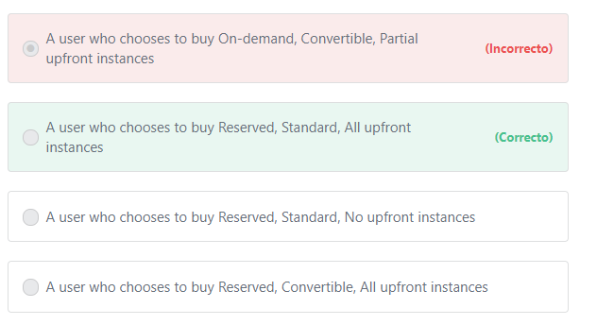

Final del formulario

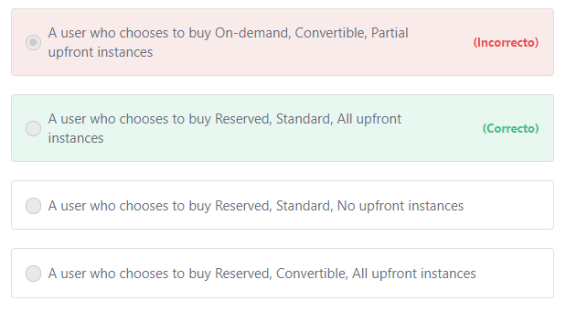Principio del formulario

**Explicación**

           Reserved instance types include:

- Standard RIs: These provide the most significant discount (up to 75% off On-Demand) and are best suited for steady-state usage.

- Convertible RIs: These provide a discount (up to 54% off On-Demand) and the capability to change the attributes of the RI as long as the exchange results in the creation of Reserved Instances of equal or greater value.

Therefore, Standard RIs provides more discounts than Convertible RIs.

              You can choose between three payment options when you purchase a Standard or Convertible Reserved Instance. With the All Upfront option, you pay for the entire Reserved Instance term with one upfront payment. With the Partial Upfront option, you make a low upfront payment and are then charged a discounted hourly rate for the instance for the duration of the Reserved Instance term. The No Upfront option does not require any upfront payment and provides a discounted hourly rate for the duration of the term.

* Remember that when you buy Reserved Instances, the larger the upfront payment, the greater the discount.

- The All Upfront option provides you with the largest discount.

- The Partial Upfront option provides fewer discounts than All Upfront.

- The No Upfront option provides you with the least discount.

***The other options are incorrect:***

***"A user who chooses to buy Reserved, Convertible, All upfront instances" is incorrect.***The Standard option provides more discounts than the Convertible option.

***"A user who chooses to buy On-demand, Convertible, Partial upfront instances" is incorrect.*** Convertible is not an On-demand option.

***"A user who chooses to buy Reserved, Standard, No upfront instances" is incorrect.*** “All upfront” provides more discounts than the “No-upfront” option.

**References:**

<https://aws.amazon.com/ec2/pricing/reserved-instances/>

<https://docs.aws.amazon.com/aws-technical-content/latest/cost-optimization-reservation-models/reserved-instance-payment-options.html>

Final del formulario

Principio del formulario

Pregunta 52:**Incorrecto**

**A company has infrastructure hosted in an on-premises data center. They currently have an operations team that takes care of identity management. If they decide to migrate to the AWS cloud, which of the following services would help them perform the same role in AWS?**

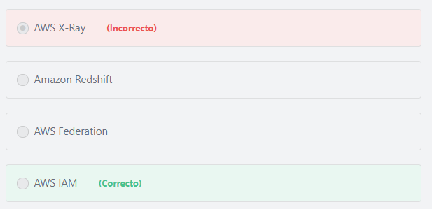

Final del formulario

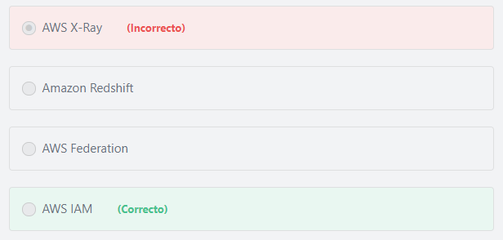Principio del formulario

**Explicación**

          AWS Identity and Access Management (IAM) is a web service that helps you securely control access to AWS resources. You use IAM to control who is authenticated (signed in) and authorized (has permissions) to access and use AWS resources.

***The other options are incorrect:***

***AWS Federation is incorrect.*** Federation is an AWS feature that enables users to access and use AWS resources using their existing corporate credentials.

***Amazon Redshift is incorrect.***Amazon Redshift provides a fully managed data warehouse in the AWS Cloud.

***AWS X-Ray is incorrect.***AWS X-Ray is used to analyze the behavior of your application by providing request tracing, exception collection, and profiling capabilities.

**References:**

<https://docs.aws.amazon.com/IAM/latest/UserGuide/introduction.html>

Final del formulario

Principio del formulario

Pregunta 53:**Correcto**

**AWS provides the ability to create backups of any block-level Amazon EC2 volume. What is the name of this backup?**

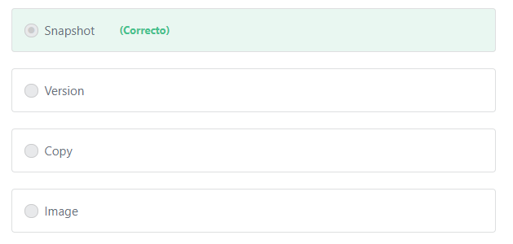

Final del formulario

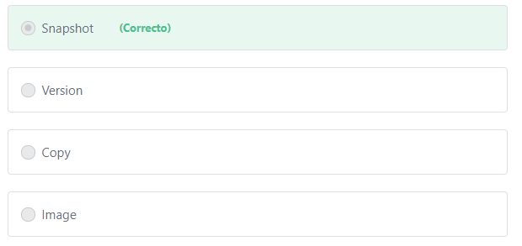Principio del formulario

**Explicación**

            The question asks for creating backups for any block-level Amazon EC2 **volume**. Amazon EC2 block-level volumes are either EBS volumes or instance store volumes. You can backup EBS volumes by creating **EBS snapshots**. Data in instance store volumes are not persistent and cannot be used to backup data. In order to backup instance store volumes you should also use EBS.

**References:**

<https://docs.aws.amazon.com/AWSEC2/latest/UserGuide/Storage.html>

Final del formulario

Principio del formulario

Pregunta 54:**Correcto**

**Which of the following S3 storage classes is most appropriate to host static assets for a popular e-commerce website with stable access patterns?**

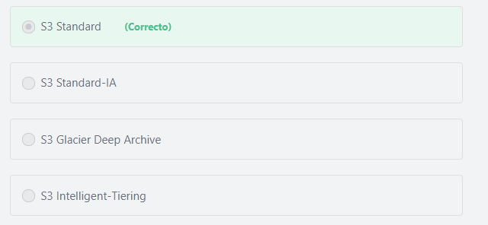

Final del formulario

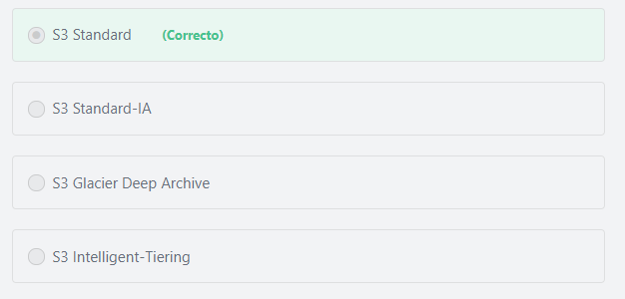Principio del formulario

**Explicación**

             S3 Standard offers high durability, availability, and performance object storage for frequently accessed data. Because it delivers low latency and high throughput, S3 Standard is appropriate for a wide variety of use cases, including cloud applications, dynamic websites, content distribution, mobile and gaming applications, and big data analytics.

***The other options are incorrect:***

***S3 Standard-IA is incorrect.***S3 Standard Infrequent Access (S3 Standard-IA) is not for popular websites. S3 Standard-IA is for data that is accessed less frequently, but requires rapid access when needed. S3 Standard-IA is ideal for long-term storage, backups, and as a data store for disaster recovery files.

***S3 Intelligent-Tiering is incorrect.*** S3 Intelligent-Tiering is the ideal storage class for long-lived data with **access patterns that are unknown or unpredictable**. It is designed to optimize costs by automatically moving data to the most cost-effective access tier (Standard and Standard-IA), without performance impact or operational overhead.

***S3 Glacier Deep Archive is incorrect.***S3 Glacier Deep Archive is Amazon S3’s lowest-cost storage class that supports long-term retention and digital preservation for data that may be accessed once or twice in a year.

**Note:**

In S3, we can only host static websites, or **static assets of a dynamic website**(such as images, audio files, video files...etc).

A dynamic website relies on server-side processing and it uses server-side scripts such as PHP, JSP, or ASP.NET. Amazon S3 does not support server-side scripting and cannot be used to host dynamic websites. AWS has computing resources for hosting dynamic websites such as Amazon EC2 or Lambda.

**References:**

<https://aws.amazon.com/s3/storage-classes/>

Final del formulario

Principio del formulario

Pregunta 55:**Incorrecto**

**What is the maximum amount of data that can be stored in S3 in a single AWS account?**

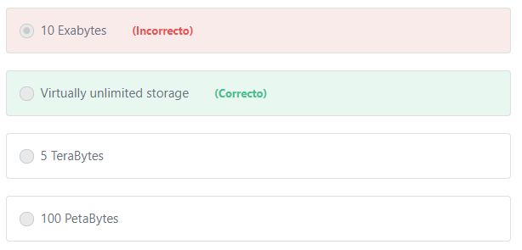

Final del formulario

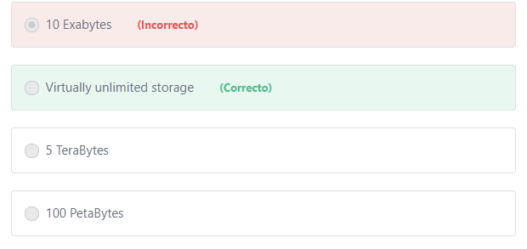Principio del formulario

**Explicación**

             The total volume of data and number of objects you can store are unlimited. Individual Amazon S3 objects can range in size from a minimum of 0 bytes to a maximum of 5 terabytes.

**References:**

<https://docs.aws.amazon.com/AmazonS3/latest/dev/Welcome.html>

Final del formulario

Principio del formulario

Pregunta 56:**Incorrecto**

**What does the Amazon CloudFront service provide? (Choose TWO)**

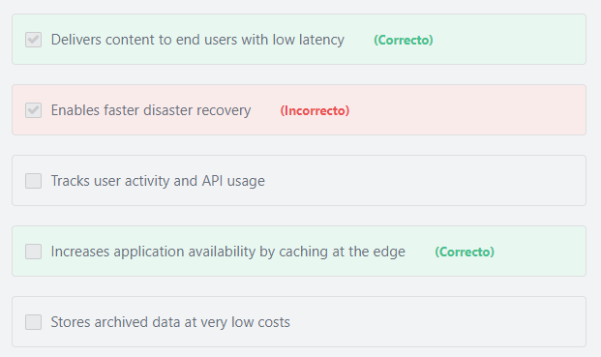

Final del formulario

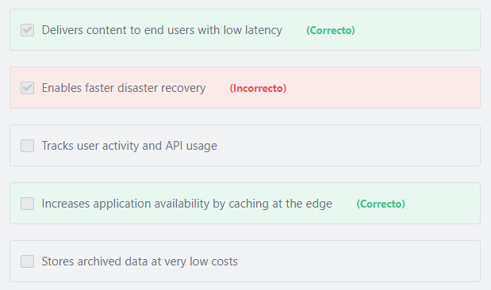Principio del formulario

**Explicación**

           "Delivers content to end users with low latency" is correct. Amazon CloudFront employs a global network of edge locations and regional edge caches that cache copies of your content close to your end-users. Amazon CloudFront ensures that end-user requests are serviced by the closest edge location. As a result, requests travel a short distance, improving performance for your end-users.

          "Increases application availability by caching at the edge" is correct. Web applications often need to contend with spikes in traffic during peak periods of activity. By using Amazon CloudFront, you can cache your content in CloudFront’s edge locations worldwide and reduce the workload on your origin by only fetching content from your origin when needed. This reduced workload on your origin helps you increase the availability of your application.

Note: An origin server is the server that holds the original, definitive versions of your content.

***The other options are incorrect:***

***"Stores archived data at very low costs" is incorrect.*** You can use Amazon Glacier to store archived data at very low costs.

***"Enables faster disaster recovery" is incorrect.*** CloudFront is not used for disaster recovery. It is used to serve content with low latency by caching copies of objects close to your end-users.

Disaster recovery is about preparing for and recovering from a disaster. Any event that has a negative impact on your business continuity or finances could be termed a disaster. This could be hardware or software failure, a network outage, a power outage, physical damage to a building like fire or flooding, human error, or some other significant disaster. In AWS, customers have the flexibility to choose the right approach that fits their budget. The approaches could be as minimum as backup and restore from the cloud or full-scale multi-site solution deployed in onsite and AWS with data replication and mirroring. Read more about disaster recovery here: <https://aws.amazon.com/blogs/publicsector/rapidly-recover-mission-critical-systems-in-a-disaster/>

***"Tracks user activity and API usage" is incorrect.*** Amazon CloudTrail is the service that can be used to track user activity and API usage.

**References:**

<https://aws.amazon.com/cloudfront/details/>

Final del formulario

Principio del formulario

Pregunta 57:**Incorrecto**

**A company experiences fluctuations in traffic patterns to their e-commerce website when running flash sales. What service can help the company dynamically match the required compute capacity to handle spikes in traffic during flash sales?**

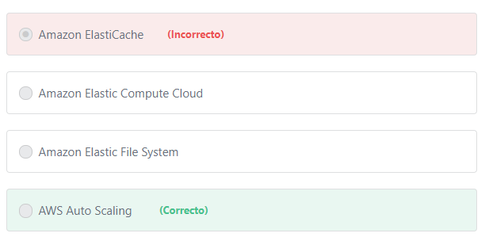

Final del formulario

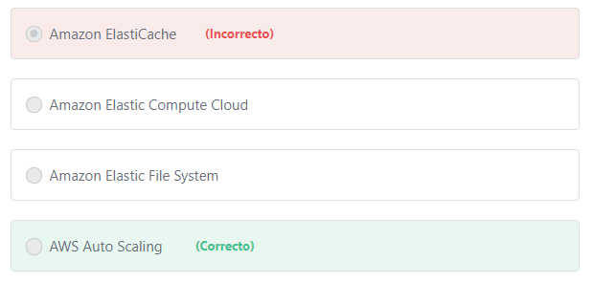Principio del formulario

**Explicación**

         AWS Auto Scaling monitors your applications and automatically adjusts capacity to maintain steady, predictable performance at the lowest possible cost. Using AWS Auto Scaling, you maintain optimal application performance and availability, even when workloads are periodic, unpredictable, or continuously changing. When demand spikes, AWS Auto Scaling automatically increases the compute capacity, so you maintain performance. When demand subsides, AWS Auto Scaling automatically decreases the compute capacity, so you pay only for the resources you actually need.

***The other options are incorrect:***

***Amazon Elastic Compute Cloud is incorrect.***Amazon Elastic Compute Cloud (EC2) is a service that provides compute capacity in the cloud.

***"Amazon Elastic File System" is incorrect.***Amazon Elastic File System (Amazon EFS) is a filelevel storage service that is designed to provide massively parallel shared access to thousands of Amazon EC2 instances, enabling your applications to achieve high levels of aggregate throughput and IOPS with consistently low latencies.

***Amazon ElastiCache is incorrect.***Amazon ElastiCache is used to improve the performance of your existing apps by retrieving data from high throughput and low latency in-memory data stores.

**References:**

<https://aws.amazon.com/autoscaling/>

Final del formulario

Principio del formulario

Pregunta 58:**Incorrecto**

**Your CTO has asked you to contact AWS support using the chat feature to ask for guidance related to EBS. However, when you open the AWS support center you can't see a way to contact support via Chat. What should you do?**

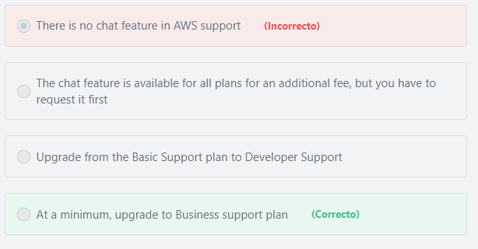

Final del formulario

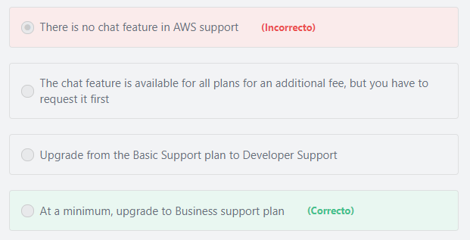Principio del formulario

**Explicación**

Chat access to AWS Support Engineers is available at the Business and Enterprise support tiers only.

**References:**

<https://aws.amazon.com/premiumsupport/compare-plans/>

Final del formulario

Principio del formulario

Pregunta 59:**Correcto**

**Which of the following services provide real-time auditing for compliance and vulnerabilities? (Choose TWO)**

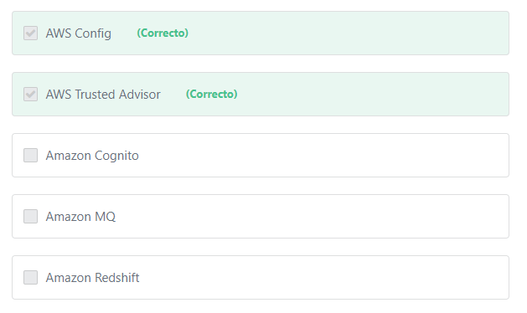

Final del formulario

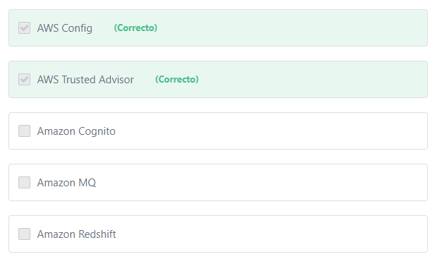Principio del formulario

**Explicación**

          Services like **AWS Config, Amazon Inspector, and AWS Trusted Advisor**continually monitor for compliance or vulnerabilities in your AWS environment which gives you a clear overview of which resources are in compliance, and which are not. With AWS Config rules you can also see if a component was out of compliance even for a brief period of time in the past, making both point-in-time and period-in-time audits very effective.

***The other options are incorrect:***

***Amazon MQ  is incorrect.***Amazon MQ is a managed message broker service for Apache ActiveMQ that makes it easy to set up and operate message brokers in the cloud.

***Amazon Redshift is incorrect.***Amazon Redshiftis a data warehousing service.

***Amazon Cognito is incorrect.***Amazon Cognito lets you add user sign-up, sign-in, and access control to your web and mobile apps quickly and easily.

**References:**

<https://aws.amazon.com/config/>

<https://aws.amazon.com/premiumsupport/technology/trusted-advisor/>

Final del formulario

Principio del formulario

Pregunta 60:**Correcto**

**Which of the following strategies help analyze costs in AWS?**

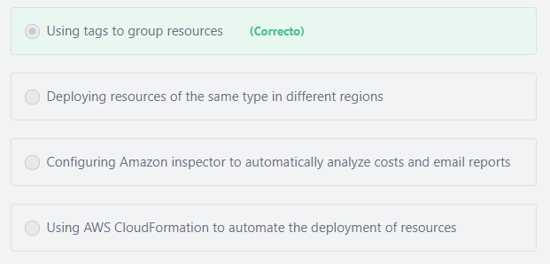

Final del formulario

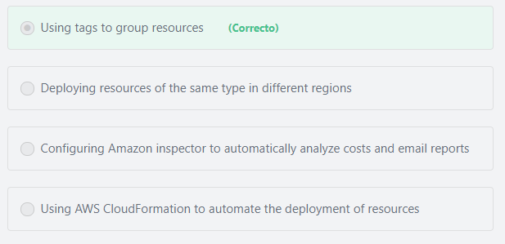Principio del formulario

**Explicación**

             Tags are key-value pairs that allow you to organize your AWS resources into groups.

You can use tags to:

1- Visualize information about tagged resources in one place, in conjunction with Resource Groups.

2- View billing information using Cost Explorer and the AWS Cost and Usage report.

3- Send notifications about spending limits using AWS Budgets.

              It is recommended to use logical groupings of your resources that make sense for your infrastructure or business. You could organize your resources by: Project, Cost center, Development environment, Application or Department. For example, if you tag resources with an application name, you can track the total cost of a single application that runs on those resources.

***The other options are incorrect:***

***"Deploying resources of the same type in different regions" is incorrect.*** Resource type is not a factor when determining which AWS Region to use. Proximity to end-users, data sovereignty, and costs are the factors that should be considered when choosing a Region.

***"Using AWS CloudFormation to automate the deployment of resources" is incorrect.*** Automating the deployment of your resources through scripts allows you to build and rebuild your infrastructure and applications, without having to perform manual actions or write custom scripts, enabling configuration compliance and faster troubleshooting.

***"Configuring Amazon inspector to automatically analyze costs and email reports" is incorrect.***Amazon inspector is not used for analyzing costs. It is a security assessment service for your applications.

**References:**

<https://aws.amazon.com/premiumsupport/knowledge-center/tags-billing-cost-center-project/>

Final del formulario

Principio del formulario

Pregunta 61:**Correcto**

**What can you use to assign permissions directly to an IAM user?**

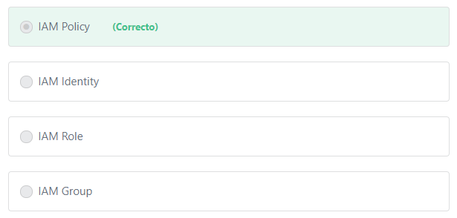

Final del formulario

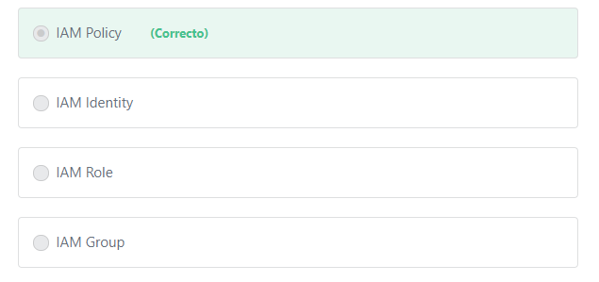Principio del formulario

**Explicación**

             A policy is an object in AWS that, when associated with an identity or resource, defines their permissions. AWS evaluates these policies when an IAM principal (user or role) makes a request. Permissions in the policies determine whether the request is allowed or denied.

Each policy consists of:

*1- Actions:*

What actions to allow or deny.

*2- Resources:*

Which resources to allow or deny the action on.

*3- Effect:*

What will be the effect when the user requests access—either allow or deny.

*4- Conditions:*

Which conditions must be present for the policy to take effect. For example, you might allow access only to the specific S3 buckets if the user is connecting from a specific IP range or has used multi-factor authentication at login.

**Note:**

Permissions are granted to IAM identities (users, groups, and roles) to determine whether they are authorized to perform an action or not.

***The other options are incorrect:***

***"IAM Role" is incorrect.*** An IAM role is an IAM identity that you can create in your account that has specific permissions. When you assume a role, it provides you with temporary security credentials for your role session. You can use roles to delegate access to users, applications, or services that don't normally have access to your AWS resources. For example, you might want to grant users in your AWS account access to resources they don't usually have, or grant users in one AWS account access to resources in another account.

***"IAM Group" is incorrect.*** You can use IAM groups to apply policies to users, however the policies are not directly attached to the IAM user. To assign permissions **directly** to an IAM user, attach an IAM policy to that user.

**Additional information:**

What is an IAM Group?

An IAM group is a collection of IAM users. Groups let you specify permissions for multiple users, which can make it easier to manage the permissions for those users. For example, you could have a group called *Admins* and give that group the types of permissions that administrators typically need. Any user in that group automatically has the permissions that are assigned to the group. If a new user joins your organization and needs administrator privileges, you can assign the appropriate permissions by adding the user to that group. Similarly, if a person changes jobs in your organization, instead of editing that user's permissions, you can remove him or her from the old groups and add him or her to the appropriate new groups.

***"IAM Identity" is incorrect.***You create IAM Identities to provide authentication for people and processes in your AWS account. IAM identities include users, roles and groups.

**References:**

<https://docs.aws.amazon.com/IAM/latest/UserGuide/access_policies.html>

Final del formulario

Principio del formulario

Pregunta 62:**Incorrecto**

**Which service can you use to route traffic to the endpoint that provides the best application performance for your users worldwide?**

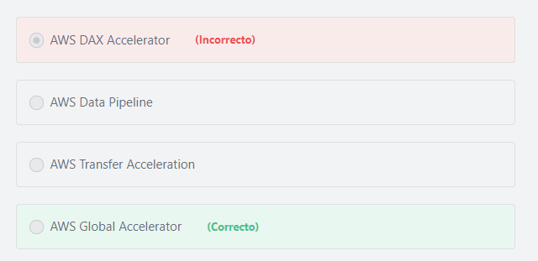

Final del formulario

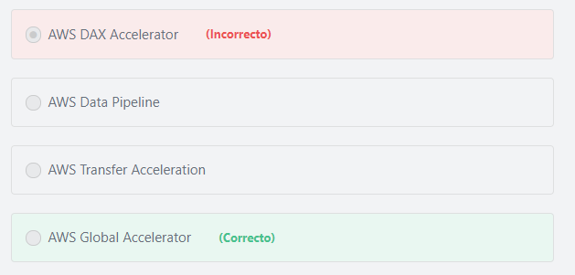Principio del formulario

**xplicación**

                 AWS Global Accelerator is a networking service that improves the availability and performance of the applications that you offer to your global users. Today, if you deliver applications to your global users over the public internet, your users might face inconsistent availability and performance as they traverse through multiple public networks to reach your application. These public networks can be congested and each hop can introduce availability and performance risk. AWS Global Accelerator uses the highly available and congestion-free AWS global network to direct internet traffic from your users to your applications on AWS, making your users’ experience more consistent. To improve the availability of your application, you must monitor the health of your application endpoints and route traffic only to healthy endpoints. AWS Global Accelerator improves application availability by continuously monitoring the health of your application endpoints and routing traffic to the closest healthy endpoints.

***The other options are incorrect:***

***AWS Transfer Acceleration is incorrect.*** Amazon S3 Transfer Acceleration is used to enable fast transfers of files over long distances between your client and an S3 bucket. You might want to use Transfer Acceleration on a bucket for various reasons, including the following: 1- You have customers that upload to a centralized bucket from all over the world. 2- You transfer gigabytes to terabytes of data on a regular basis across continents. 3- You are unable to utilize all of your available bandwidth over the Internet when uploading to Amazon S3.

***AWS DAX Accelerator is incorrect.*** Amazon DynamoDB Accelerator (DAX) is an in-memory cache for DynamoDB that delivers up to a 10x performance improvement – from milliseconds to microseconds – even at millions of requests per second.

***AWS Data Pipeline is incorrect.***AWS Data Pipeline is a web service that helps you reliably process and move data between different AWS compute and storage services, as well as on-premises data sources, at specified intervals. AWS Data Pipeline helps you easily create complex data processing workloads that are fault tolerant, repeatable, and highly available. With AWS Data Pipeline, you can regularly access your data where it’s stored, transform and process it at scale, and efficiently transfer the results to AWS services such as Amazon S3, Amazon RDS, Amazon DynamoDB, and Amazon EMR.

**References:**

<https://d0.awsstatic.com/whitepapers/aws-overview.pdf>

Final del formulario

Principio del formulario

Pregunta 63:**Correcto**

**Which of the below options is true of Amazon VPC?**

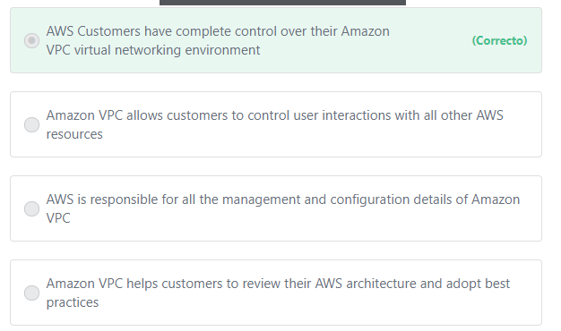

Final del formulario

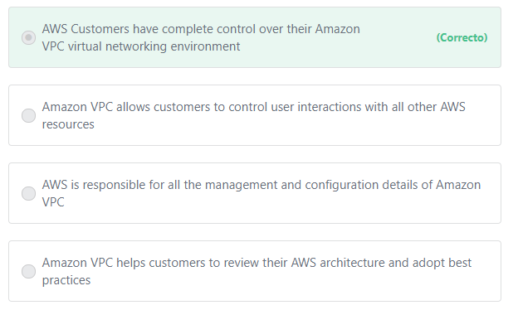Principio del formulario

**Explicación**

          Amazon Virtual Private Cloud (Amazon VPC) lets you provision a logically isolated section of the AWS Cloud where you can launch AWS resources in a virtual network that you define. You have complete control over your virtual networking environment, including selection of your own IP address range, creation of subnets, and configuration of route tables and network gateways.

***The other options are incorrect:***

***"Amazon VPC helps customers to review their AWS architecture and adopt best practices" is incorrect.***Amazon VPC does not perform this function. The AWS Well-Architected Tool is the service that helps AWS Customers review their workloads against current AWS best practices and provides advice on how to architect their workloads for the cloud.

Note: What is a workload in AWS? A workload is the collection of resources and code that make up a cloud application.

***"​Amazon VPC allows customers to control user interactions with all other AWS resources" is incorrect.***Amazon VPC does not allow customers to control user interactions with all other AWS resources. AWS IAM is the service that allows customers to perform this function.

***"AWS is responsible for all the management and configuration details of Amazon VPC" is incorrect.*** AWS Customers are responsible for all the management and configuration details of Amazon VPC, not AWS.

**References:**

<https://aws.amazon.com/vpc/>

Final del formulario

Principio del formulario

Pregunta 64:**Incorrecto**

**Which of the following is NOT a factor when estimating the cost of Amazon CloudFront?**

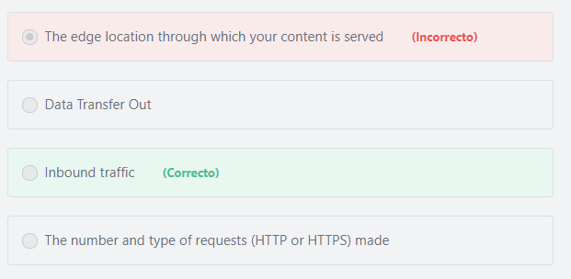

Final del formulario

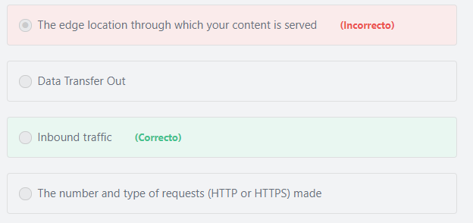Principio del formulario

**Explicación**

              Amazon CloudFront charges are based on the data transfer out of AWS and requests used to deliver content to your customers. There are no upfront payments or fixed platform fees, no long-term commitments, no premiums for dynamic content, and no requirements for professional services to get started. There is no charge for data transferred from AWS services such as Amazon S3 or Elastic Load Balancing.

            When you begin to estimate the cost of Amazon CloudFront, consider the following:

- Traffic distribution: Data transfer and request pricing varies across geographic regions, and pricing is based on the edge location through which your content is served.

- Requests: The number and type of requests (HTTP or HTTPS) made and the geographic region in which the requests are made.

- Data transfer out: The amount of data transferred out of your Amazon CloudFront edge locations.

**References:**

<https://d1.awsstatic.com/whitepapers/aws_pricing_overview.pdf>    page 16

Final del formulario

Principio del formulario

Pregunta 65:**Correcto**

**Which tool can a non-AWS customer use to compare the cost of on-premises environment resources to AWS?**

Final del formulario

#### Explicación

             The AWS TCO Calculator helps you evaluate the savings from using AWS and compare an AWS Cloud environment to on-premises and co-location environments. This tool considers all the costs to run systems in the cloud, including physical facilities, power, and cooling, to provide a realistic, end-to-end comparison of your costs.

**The other options are incorrect:**

**AWS Budgets is incorrect.** AWS Budgets gives you the ability to set custom budgets that alert you when your costs or usage exceed (or are forecasted to exceed) your budgeted amount.

**AWS Simple Monthly Calculator is incorrect.** The AWS Simple Monthly Calculator helps customers and prospects estimate their monthly AWS bill more efficiently. AWS Simple Monthly Calculator does not provide cost comparisons between AWS and on-premises environments.

**AWS Cost Explorer is incorrect.**AWS Cost Explorer lets you dive deeper into your AWS cost and usage data to identify trends, pinpoint cost drivers, and detect anomalies.

**References:**

<https://aws.amazon.com/tco-calculator/>